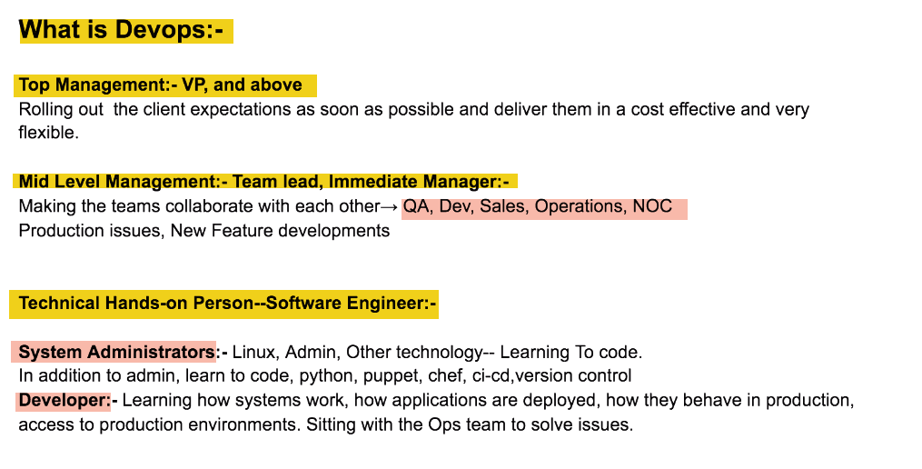 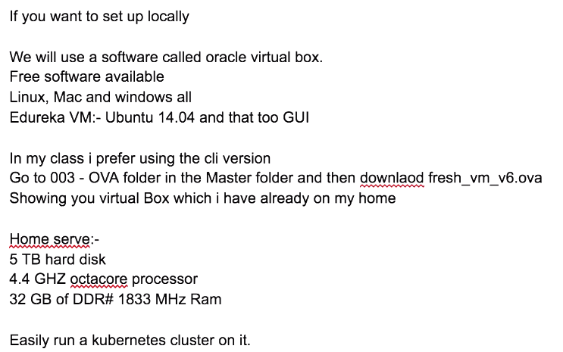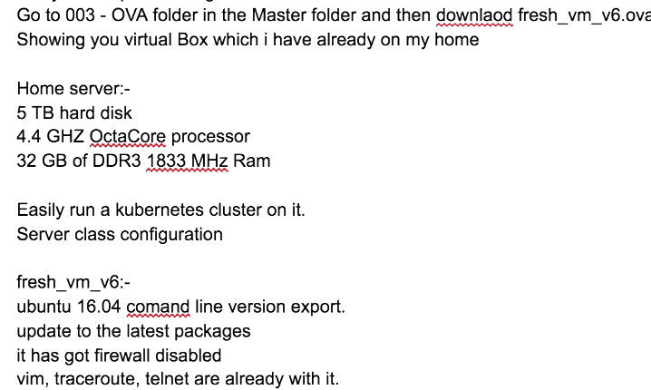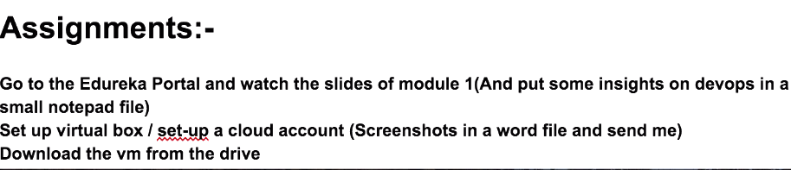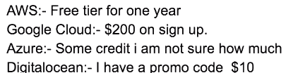

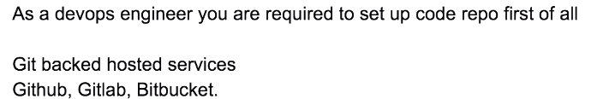

**First ask your company code repo…On Github???...Instead advice to put it on Git/gitlab on AWS server**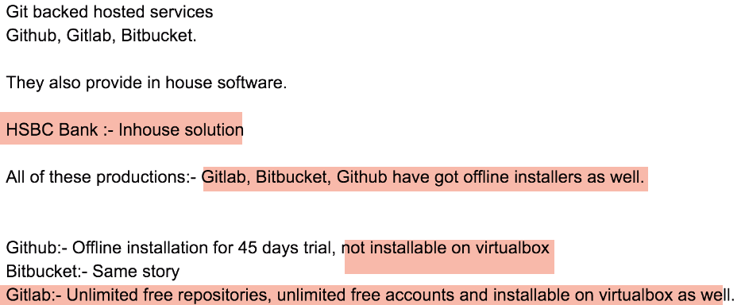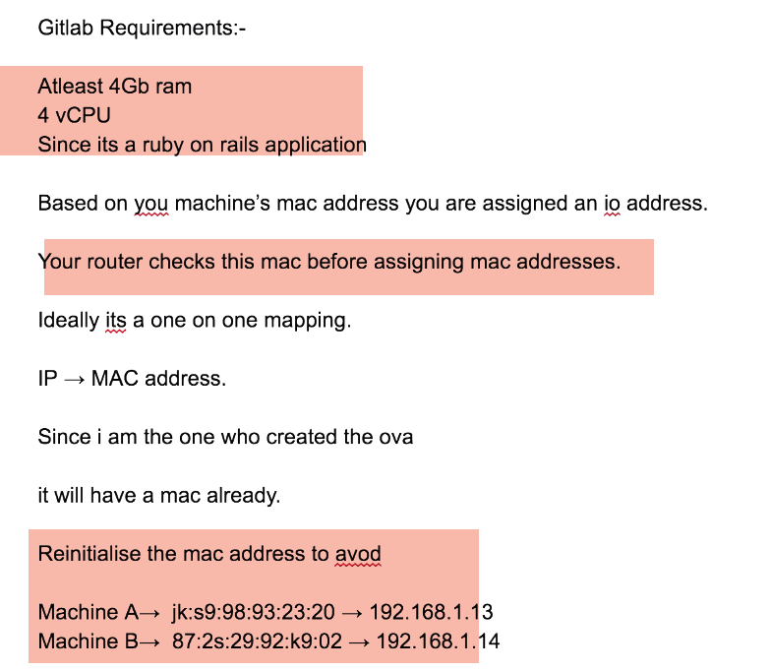

**puTTy🡪Personal user TTy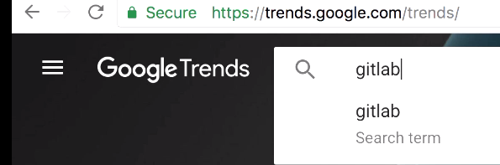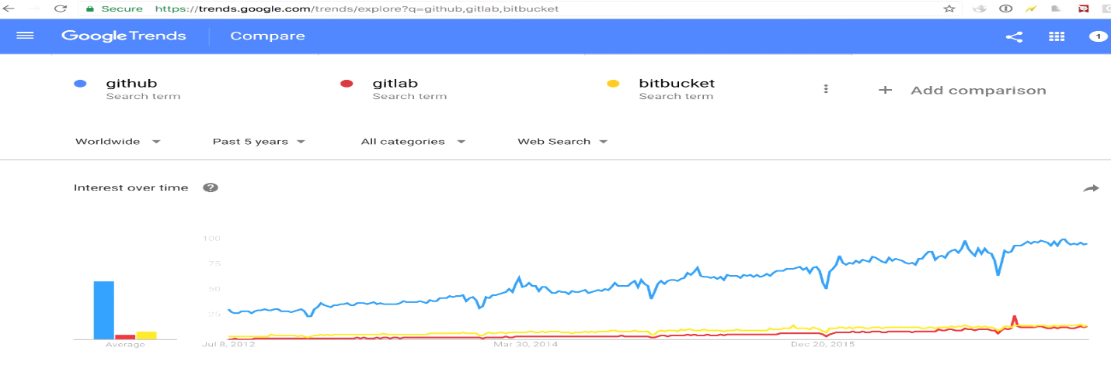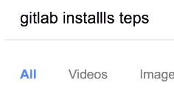1.)**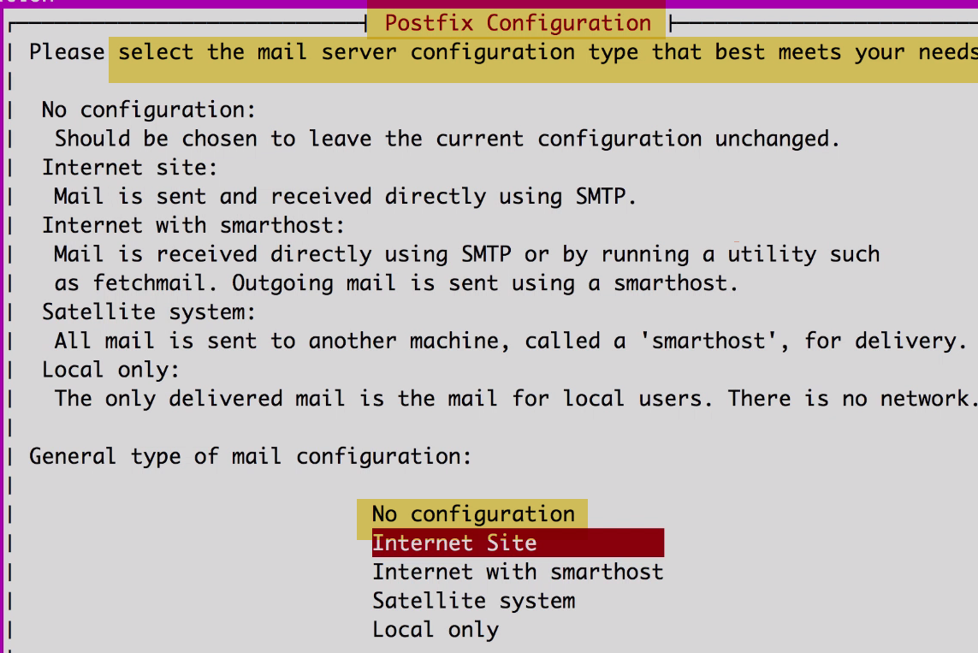

It installed postfix, which is mail server actually. It is used by gitlab to send mails to respective stack holders for any issues or comments.

We are using gitlab for lab... We don’t need this…Select🡪No Configuration.

2.) 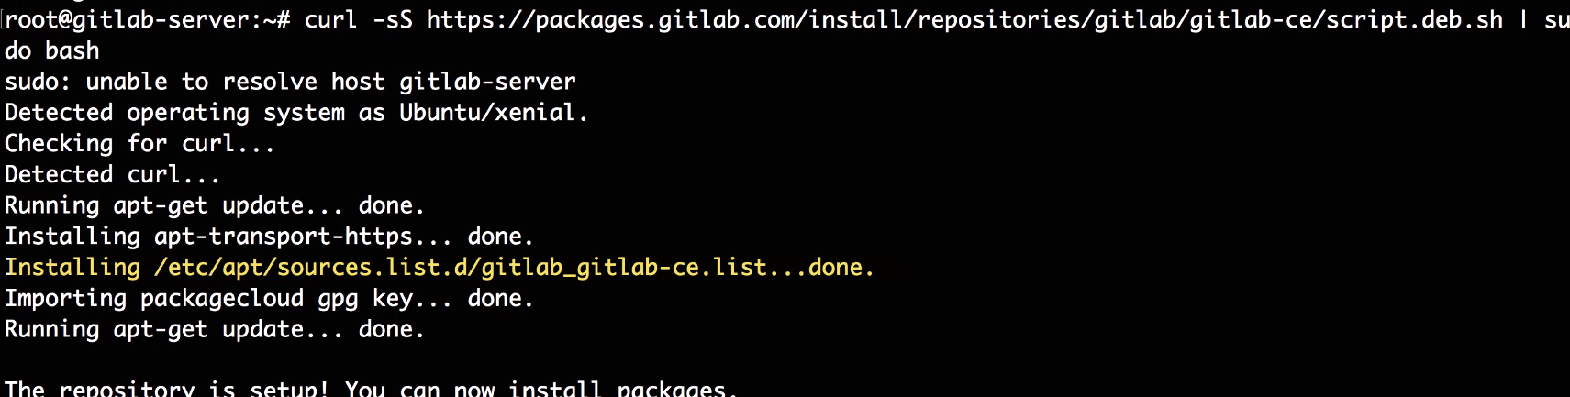

See there is list file created in:

What it is telling is: IF you want to install gitlab, go to internet to this repo..a this install gitlab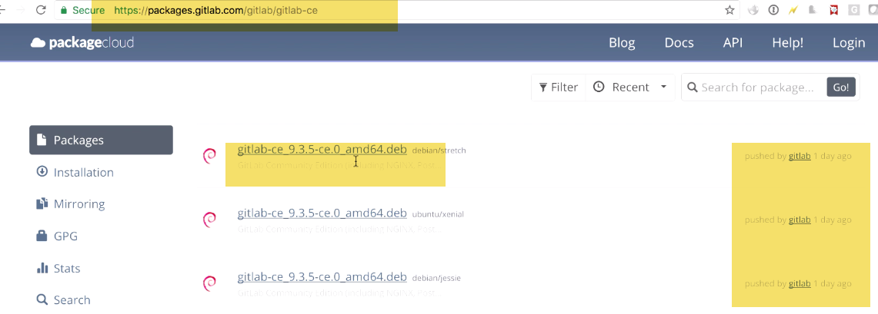 Pushed 1 DAY go🡺 they practice CI, and PUBLISH everyday

3.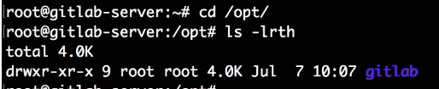

4.)  

Configuration: Since gitlab is oftware which listens on fron t end ,it should know IP which it should listen on..--**-Change to**



This will tell gitlab to listen on external URL

Run this again: 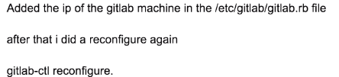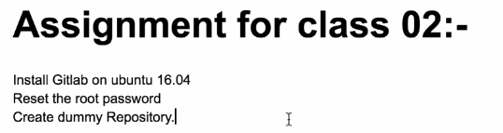

QQQ:: Can some one tell me logical step from here..Can I go to frontend and look for(On browser🡪ip)??

Will it show frontend here???Yes/NO??

Will it instal webserver??webserver is inbuilt into gitlab installation..,done by chef.

It is accessible using port 80 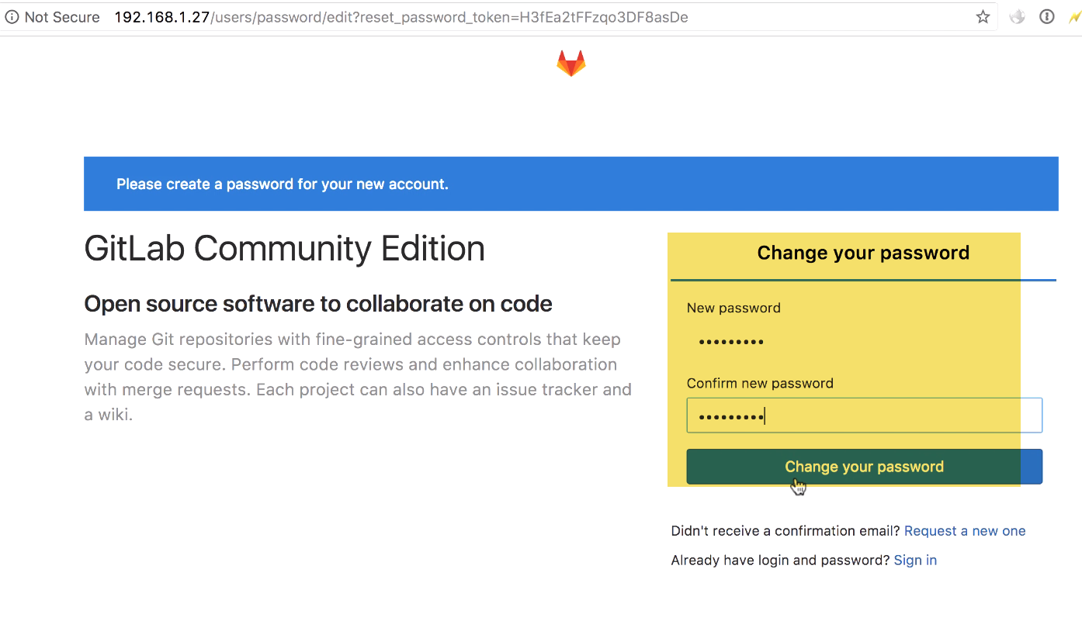

It will prompt for Change password-🡪Password change is for default ‘root’ user.

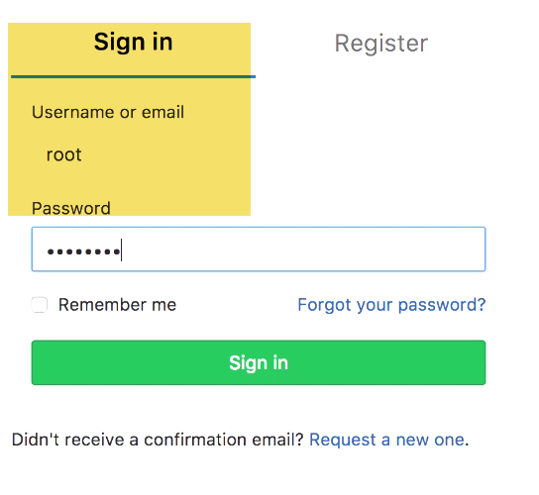

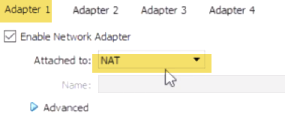 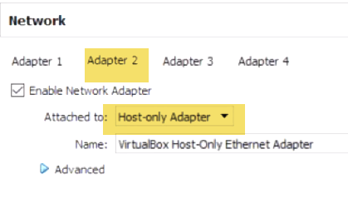 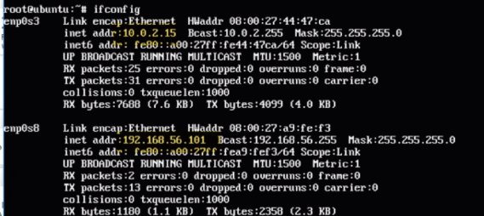

Hardware compatability or driver issue..

Apt-get update(have internet access)

10 series🡪NAT.It is using your Laptop IP which is assigned to laptop IP router.

It is using NAT for internet access and for ssh access, creating host-only n/w.

**Now, there are 2 n/w cards attached to machine now..1 for internet, other for putty access**

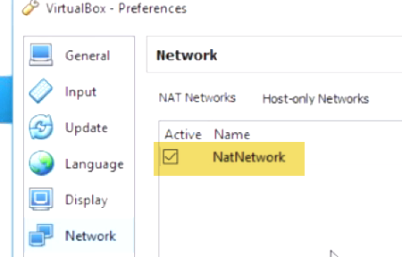 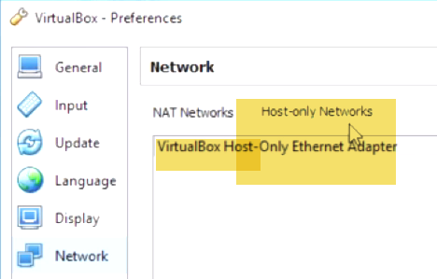

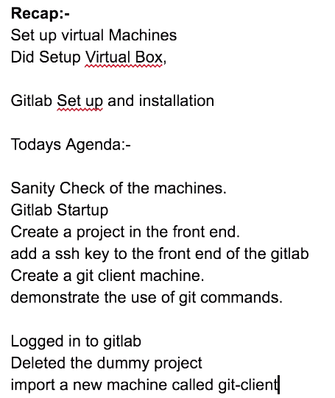 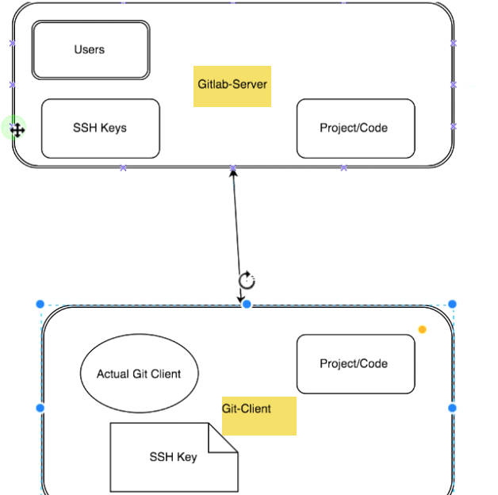 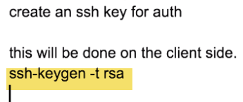**Do from Client side**

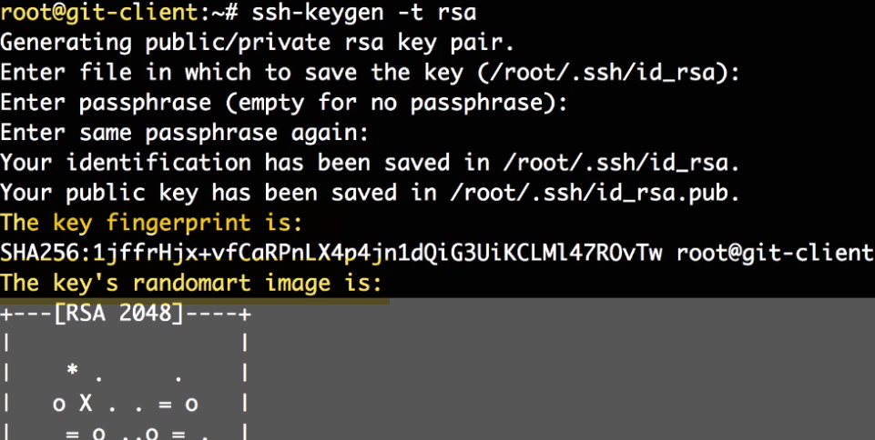 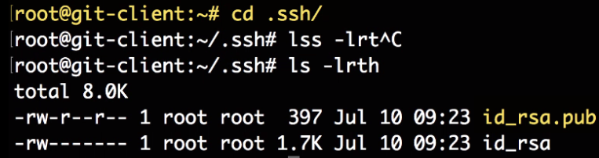

Now put .pub file on server for authentication …Public key can be given to anyone

PRIVATE KEY DON’T SHARE

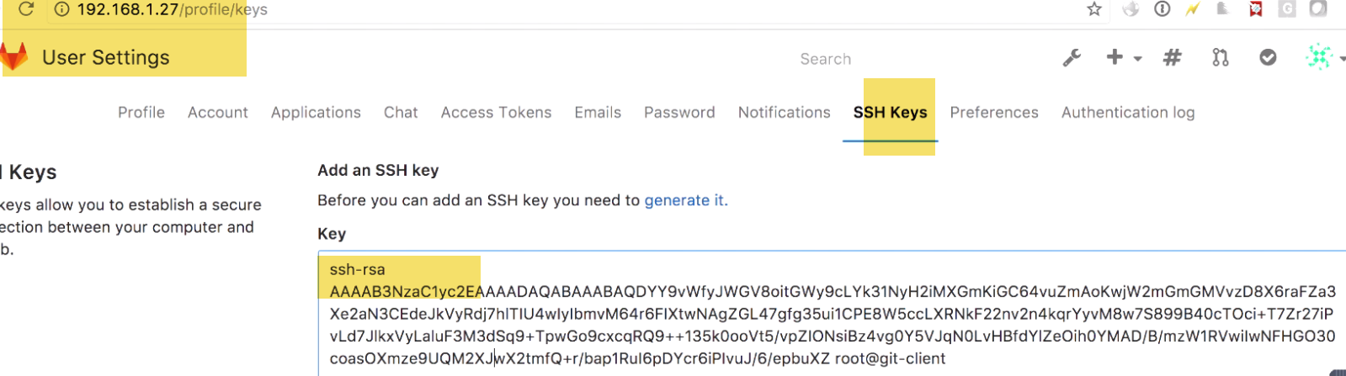

<http://www.techoism.com/how-to-install-gitlab-on-centosrhel/>

<https://about.gitlab.com/installation/#centos-7>

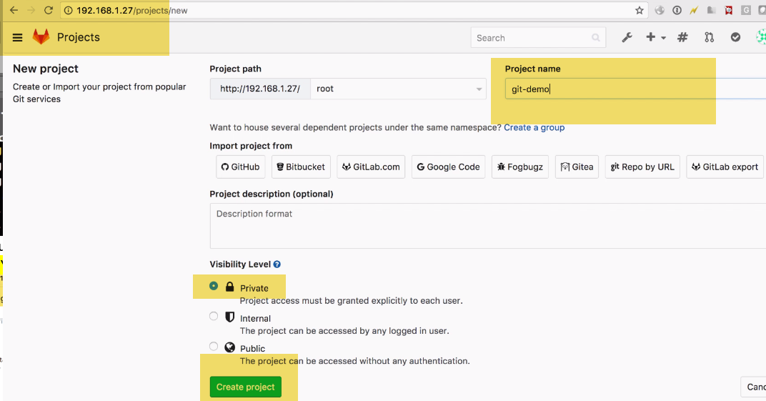

2 ways to clone repo:

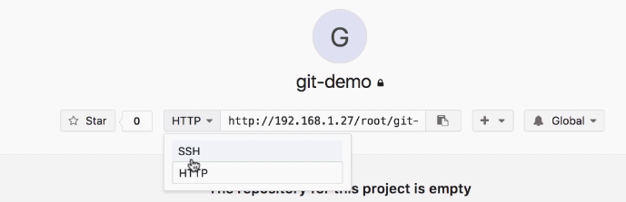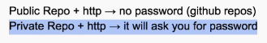🡪 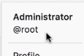Password is login which we logge in git repo.

We can create common key ans scp over all m/c..

**Client side**: 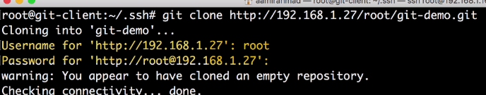

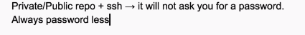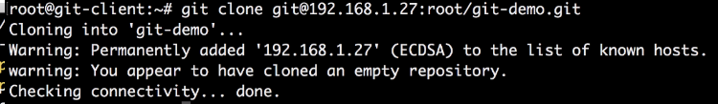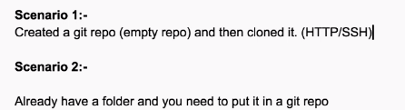

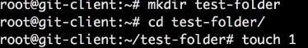

Git Flow

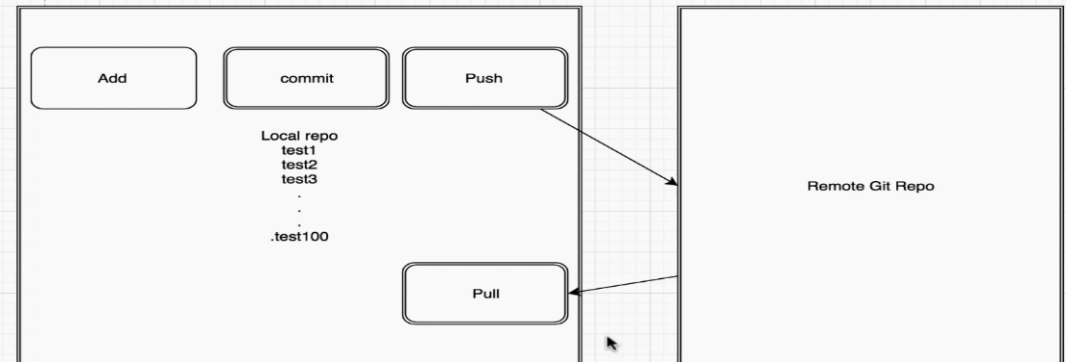

Except Pull,push every other commands ARE LOCAL

My local repo doesn’t have reference to remote repo..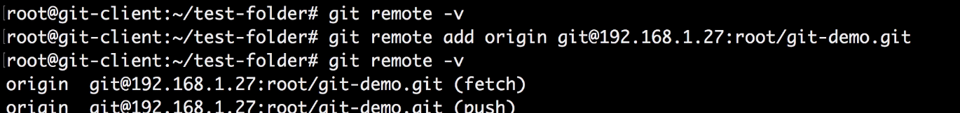 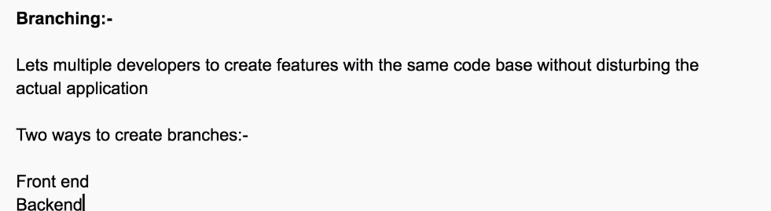

From Frontend:

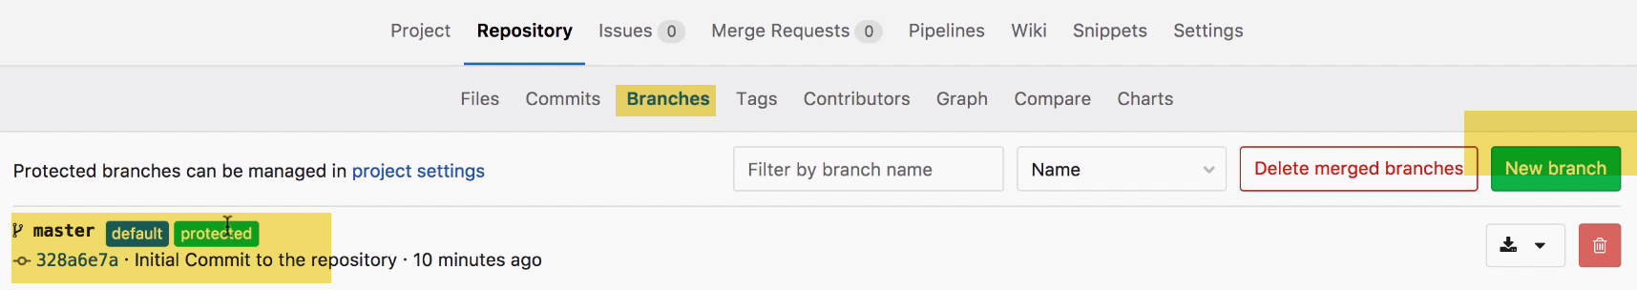

We have master branch(Default), **protected branch (people with admin access can also commit to).It’s way to protect Code from unauthorized access.**

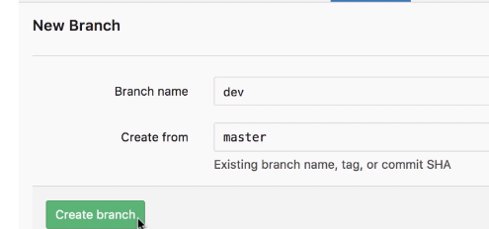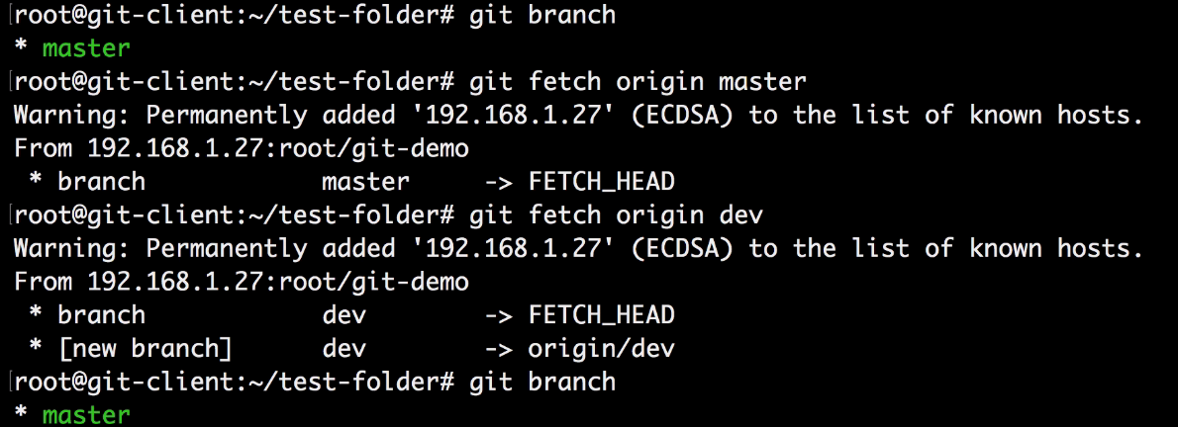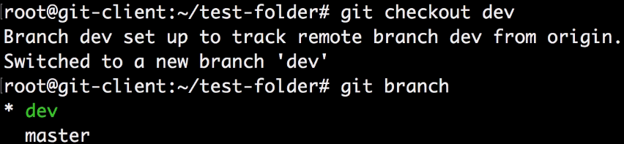

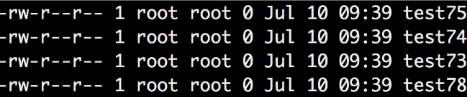

**It have all files inside it..**

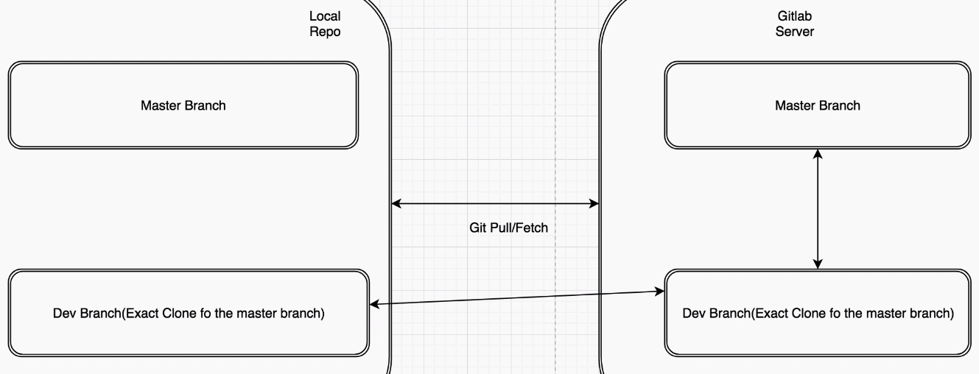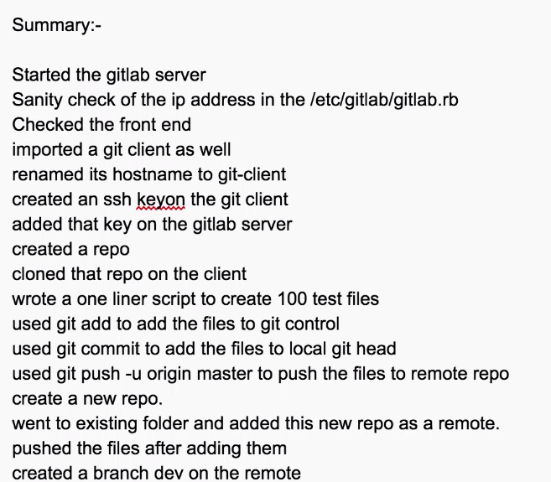

**----Git commands**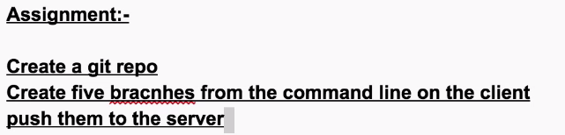

# **Class-4**

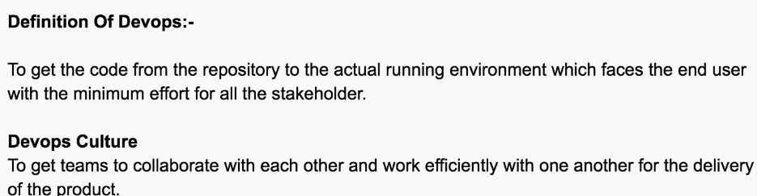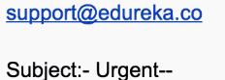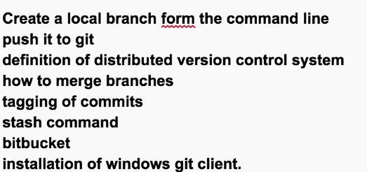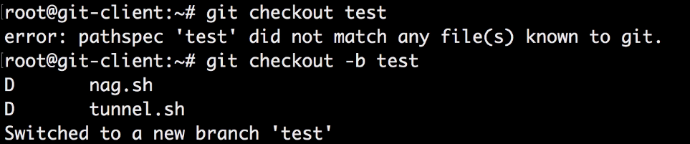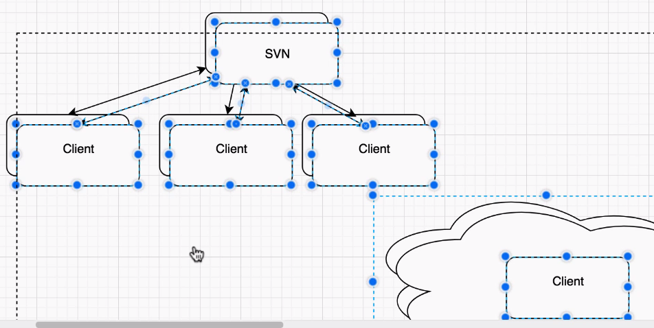

Client is ingle---cannot work

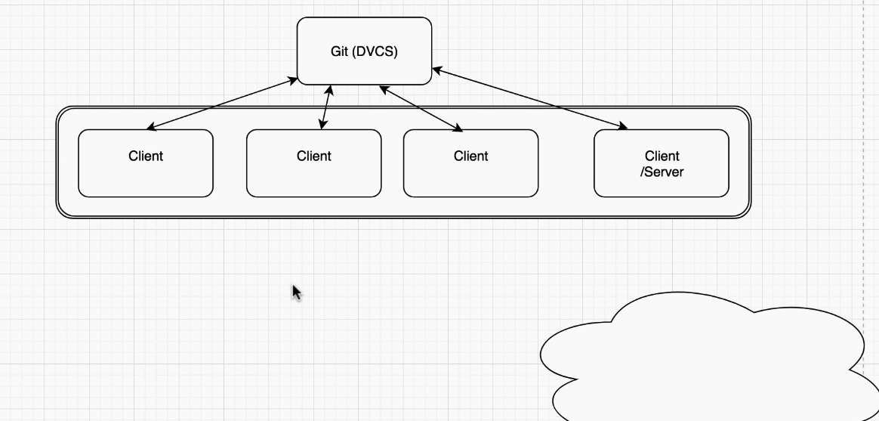

In DVCS🡪 Client can act as server…

Cn work in jungle..and can push his commits

**-----🡪MERGE:**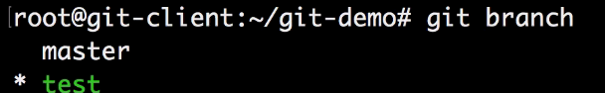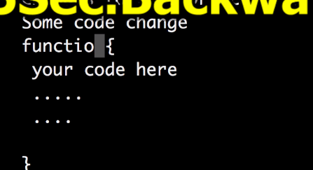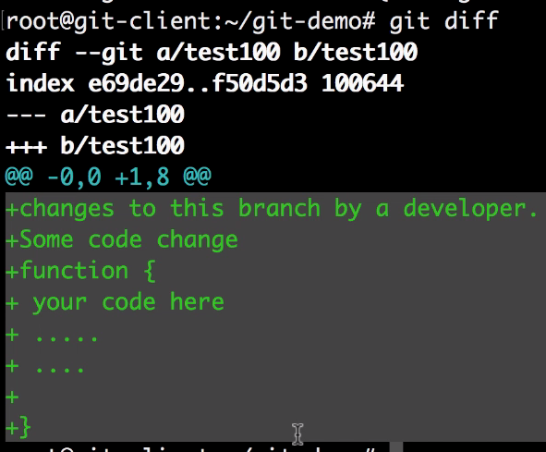

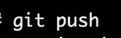

Merge with master🡪 because master is only deployed to prod..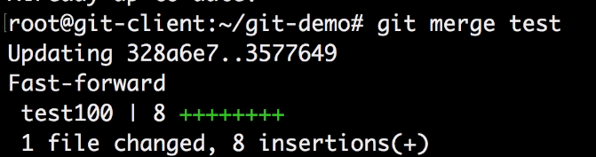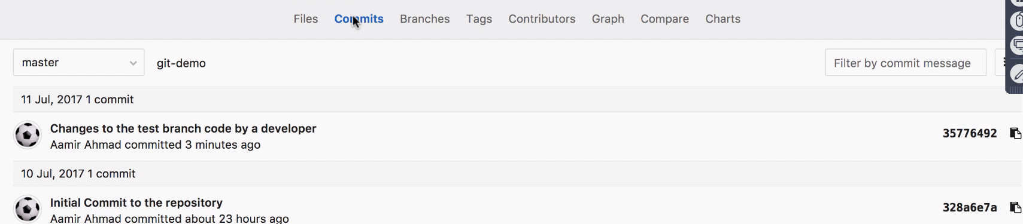

**Verify commits also merged**

**-🡪Tagging:**

**Keeps tracks of changes... Your s/w have release cycle. And have versions 2.0, 3.0 and want to release in Prod or new environment..**

**Before releasing tag it**

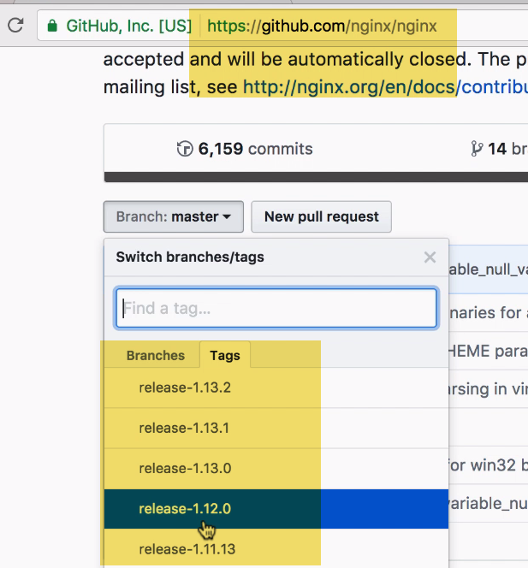

**See nginx example: Tagging is like bookmarking release**

**When I click on 1.12.2 or 1.13.0🡪 it will take to that release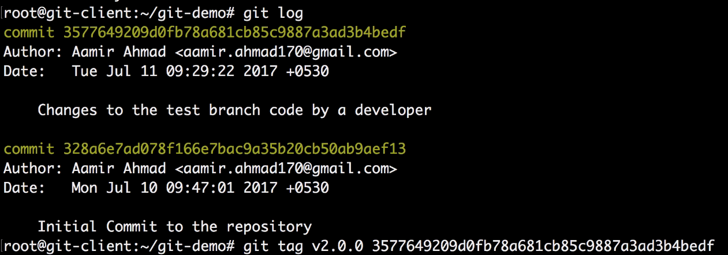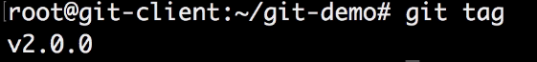...**

**On remote repo--🡪**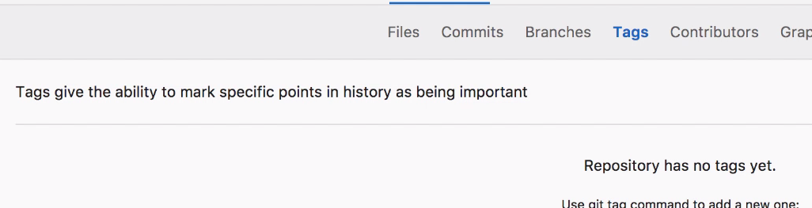

**No tag there🡪 How to push tag???**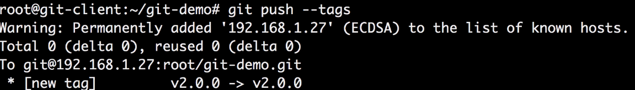

**Push all tags from local to remote repo..**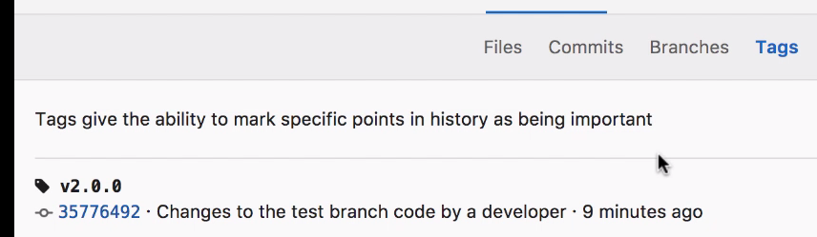

**-🡪Stash (let say you’re working in Directory, not committed to any branch..**

Manager comes and say some Prod issue.. Now need to switch branch(But changes in local branch not saved or committed)..It have takesn sleepless nights and 3 days.. Trash that all changes???

For this we have stash🡪 local temp. storage like drawers in almirah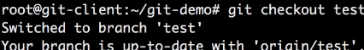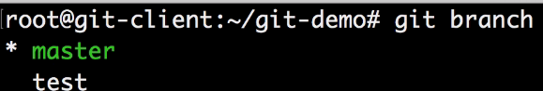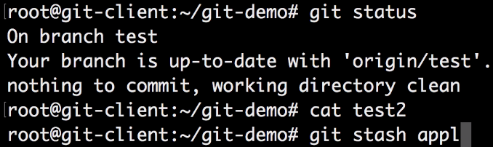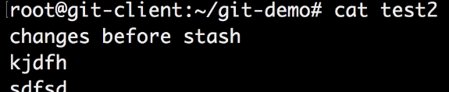

-🡪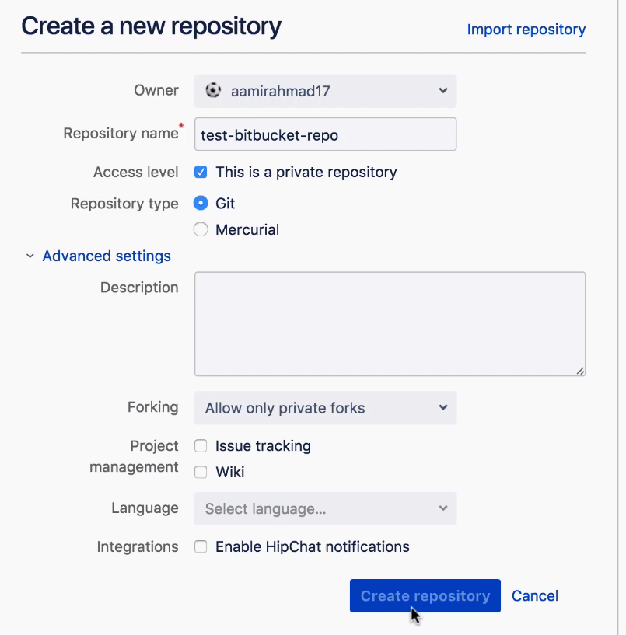

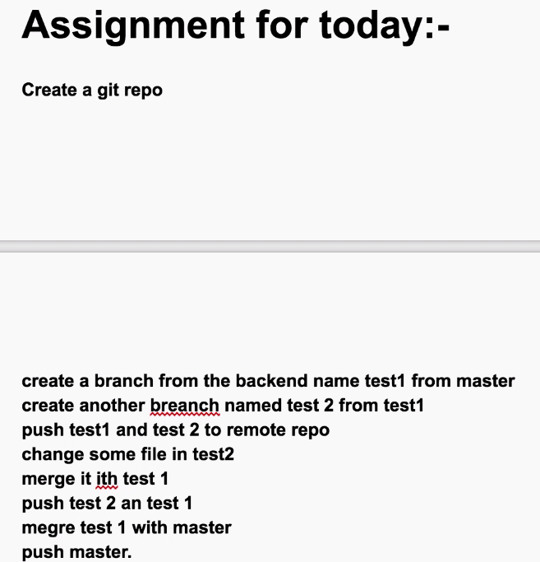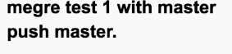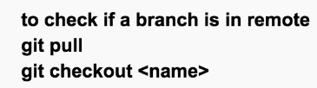

--Can we create branch from a particular commit??

Checkout from branch.. revert to prev. commitid

We have mater..create dev br from master..From dev, checkout to particular commitid..

---Can we have multiple stashes??—Yes

But can be conflits ---It applies one over other

---Std. git structure for Devt..???

Dev, test, preprod, int, prod branches..

For bugfixes---fix branch, feature branches. Hotfix br..

---How to protect branches(prevent from merging).

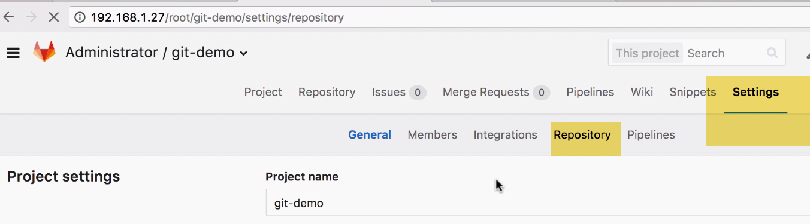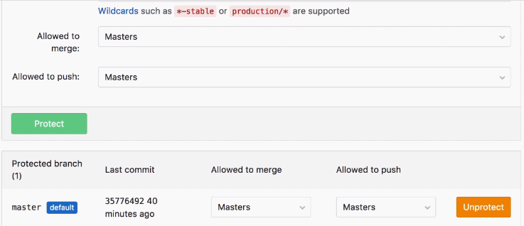

When protected, it will create merge request, when someone try to do…

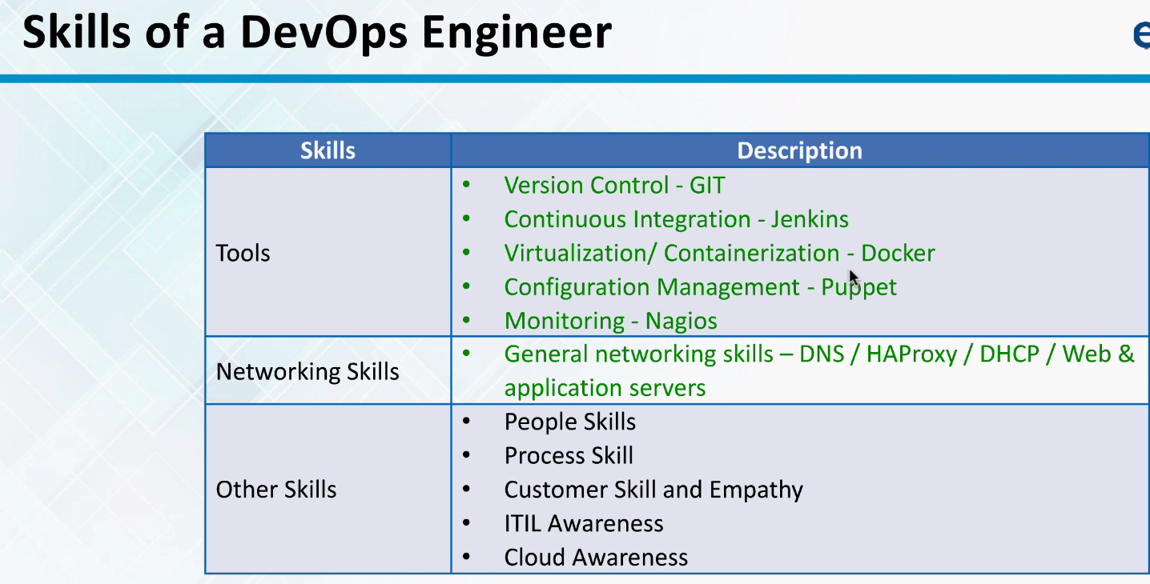

CI vs COnt.Deployemnet

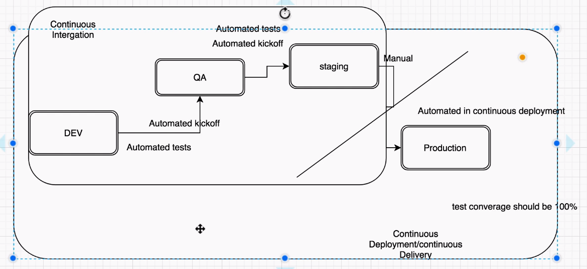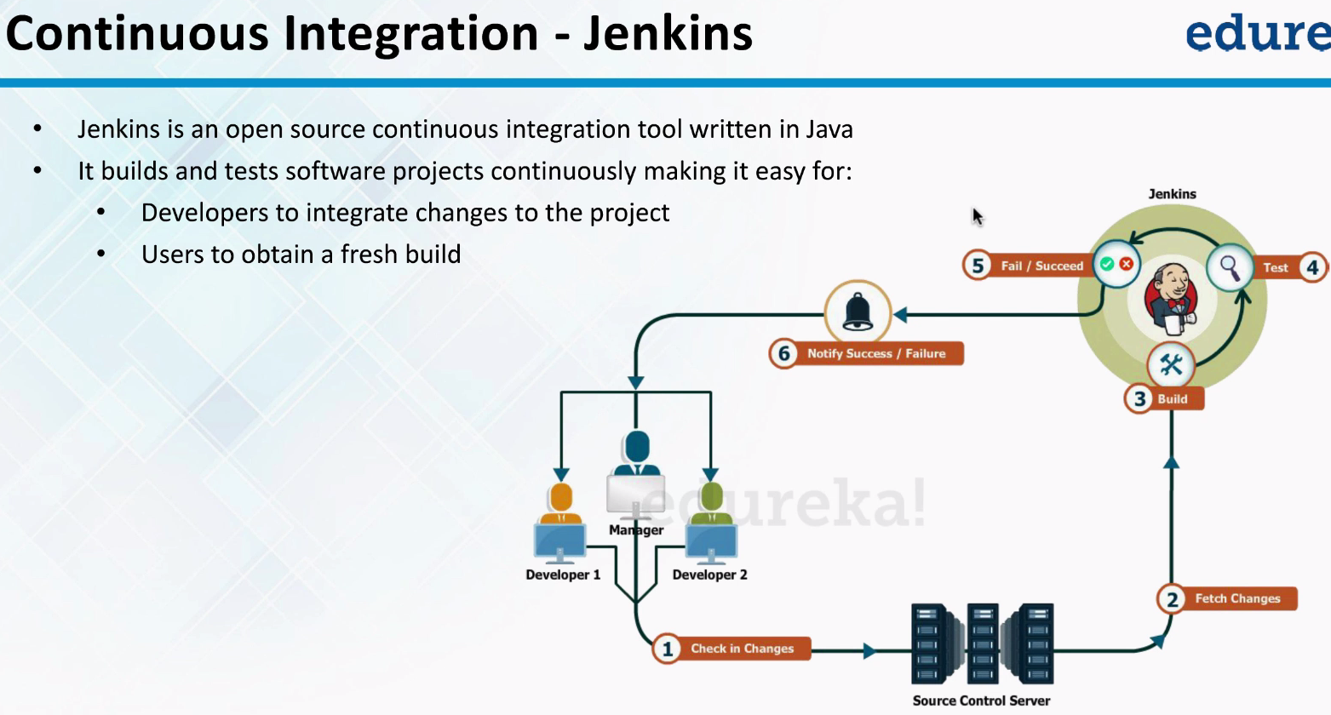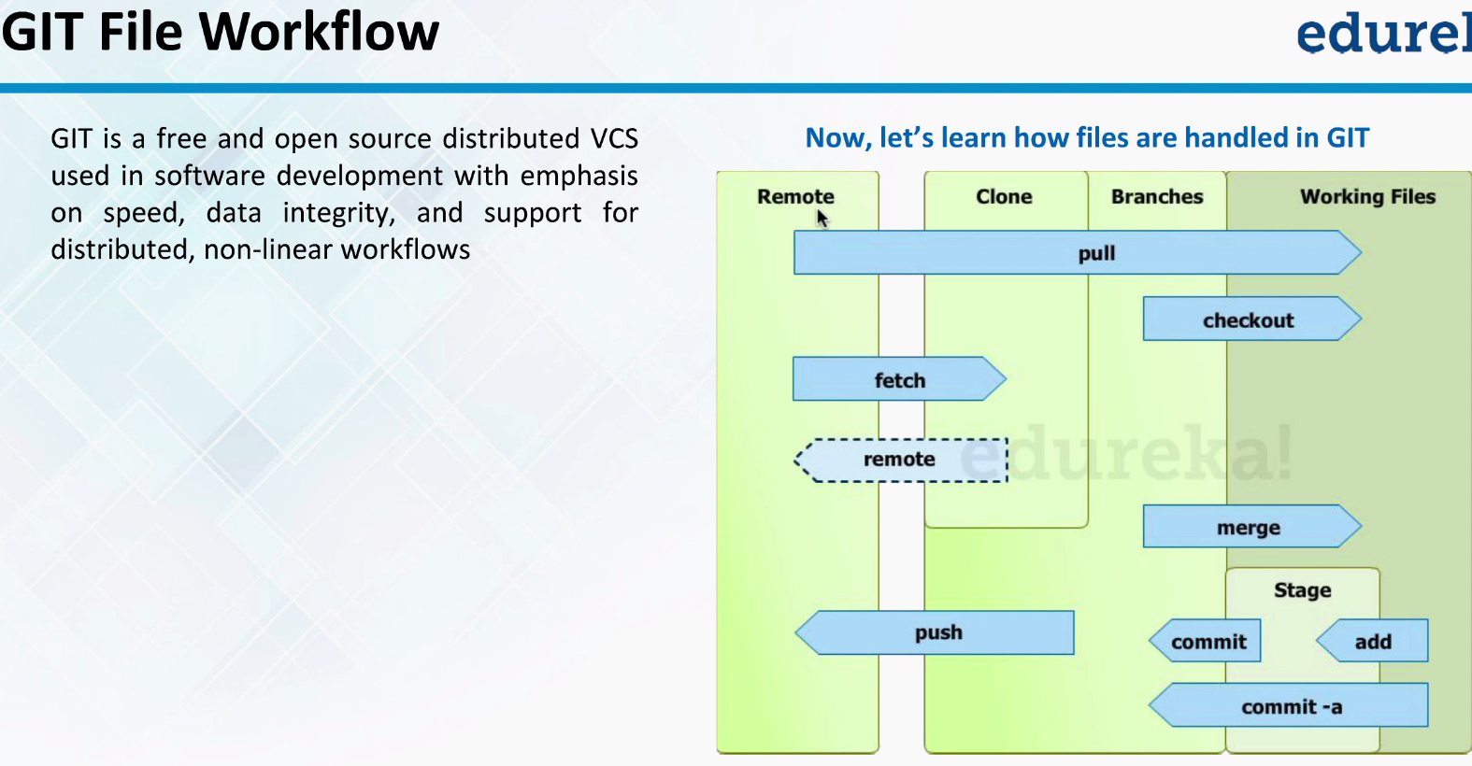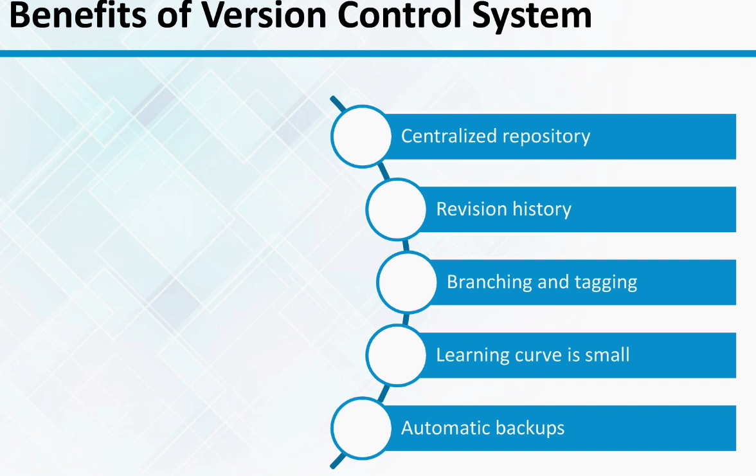



How to migrate from github to gitlab

-🡪Before use to have code on github (paying 200$ for month).Better to have code inhouse hosted on aws..We have great devops team..Why cant we handle it??

What’s min. value for gitlab on aws???

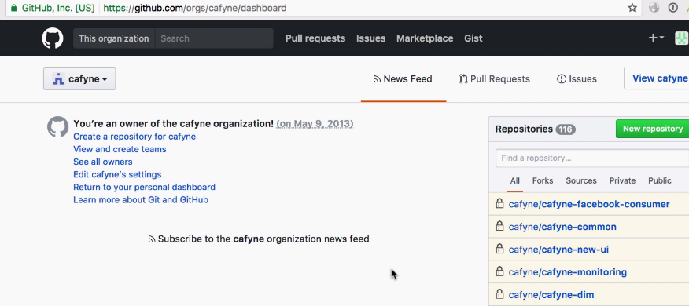

We calculated cot using “Cost calculator AWS and github”

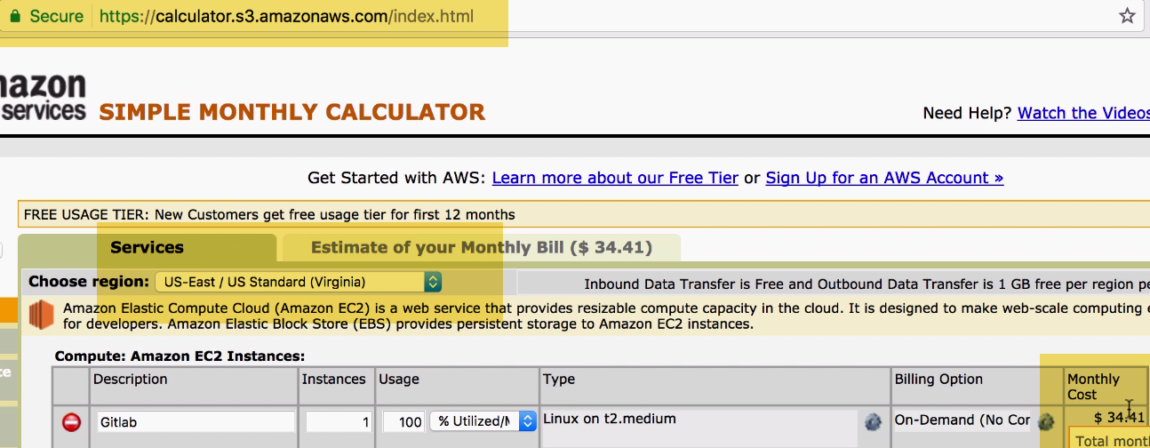

How can you guarantee ..No doentime or loss of code there??

----Demo:Goto github

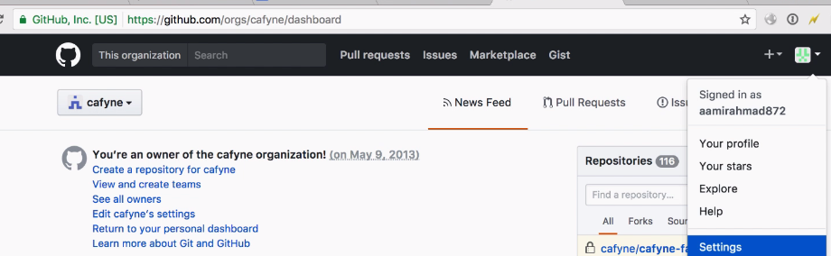

Create Oath token…Personal token

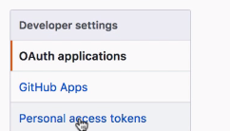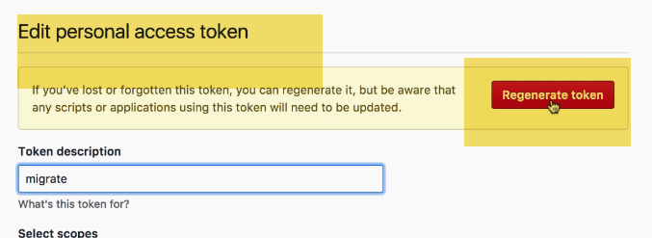

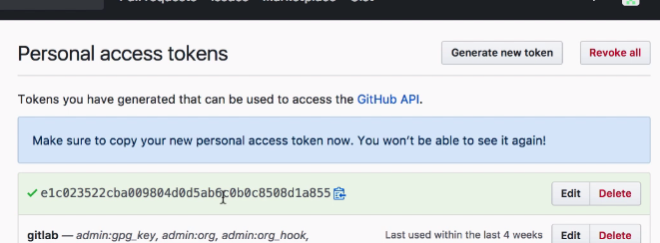

This is token which github gives you to authenticate with gitlab api..

On gitlab:

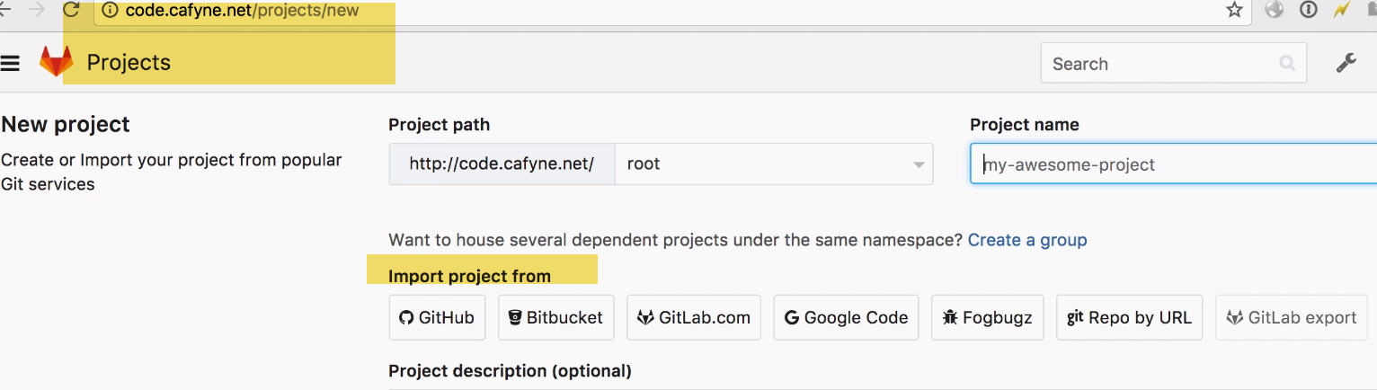

We can import all repo…and all histories with single goo…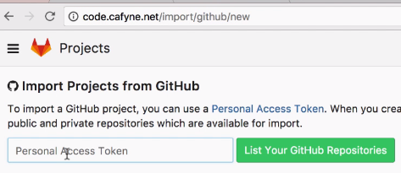Click Import from github., and paster personal token here…

Click Github repos…

It will Goto Github and lists all repos

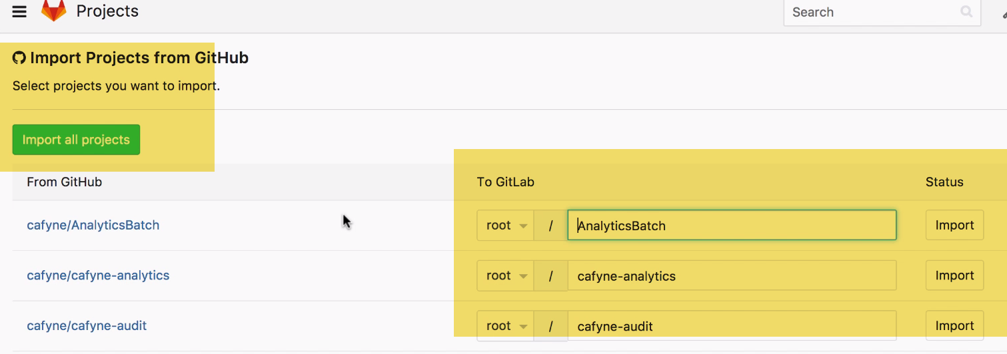

Import what are required..

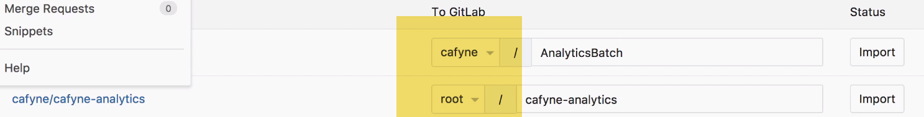

You just cant import to root account

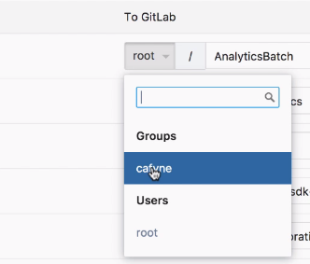 We have options to choose…Never import to root a/c..None will have access ..So????

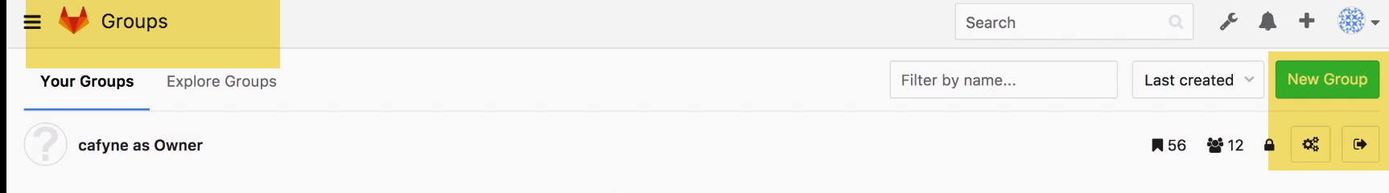

Go to groups and create new group

How do u map users???...No Way

**Best way is: USE SAME ID FOR GITLAB, AS WE SIGN IT TO GITHUB ALSO.It will map commits..But not users**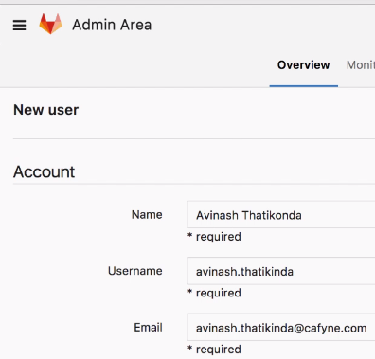

2.)LDAP

3.) We can use github API..Which wil give list of users of our a/c in JSON

We can then import into gitlab

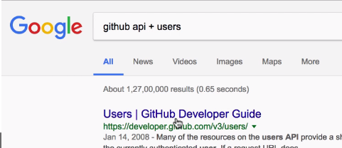

4.) From github…Import users using Github API into excel.Then import this excel into AD

DEMO ------------

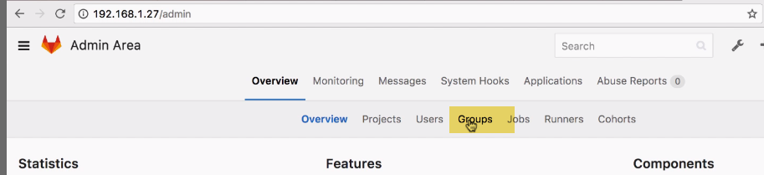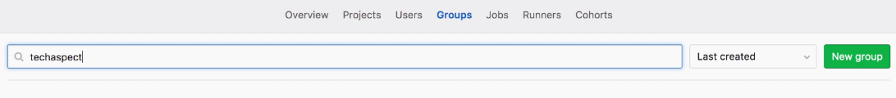

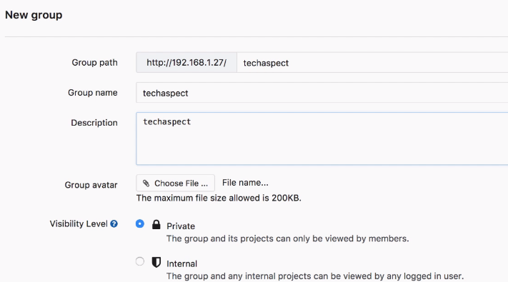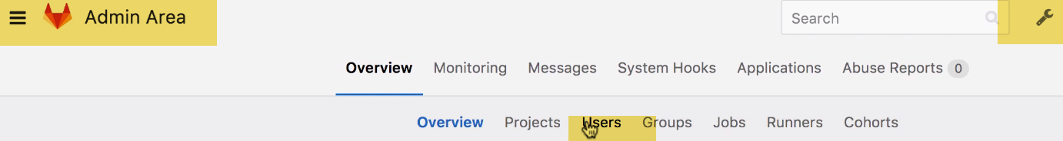



1.)When we have people not in org… (contractors)---Doesn’t show any private repo.. unless granted

Some people hired for UI work. Created separate group for them, and created external users which doent allows to access any private repos..

2.) We can control at group level also..

We can control access at group level than user level using GROUPS..

Jenkins user which can pull and push to all repo…So made as owner/admin



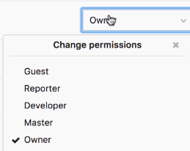Ideally master should also do.

Guest: We can mention period of time, he can have access.Just see code

Reporter: Report issues…Can push also

Developer; psuh to un protected branches..

Master: can push to protected ones..Cannot delete/create repos..

Owner: can do everything..Add access to group

A project can be member of one or 2 groups

-🡪 Go to existing project (say git-demo)🡪settings🡪Add groups

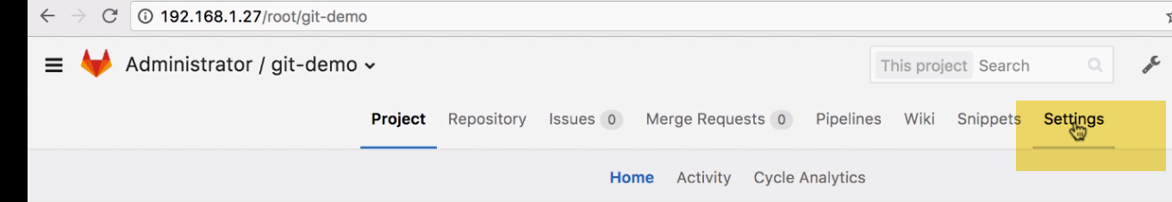

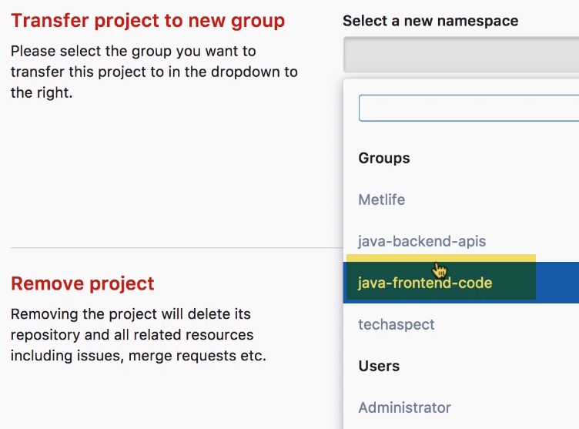

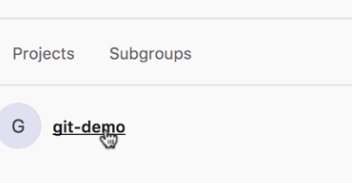

**Issue-2:**

**1.) Automatically backup Snapshots**

We can select automatic snapshots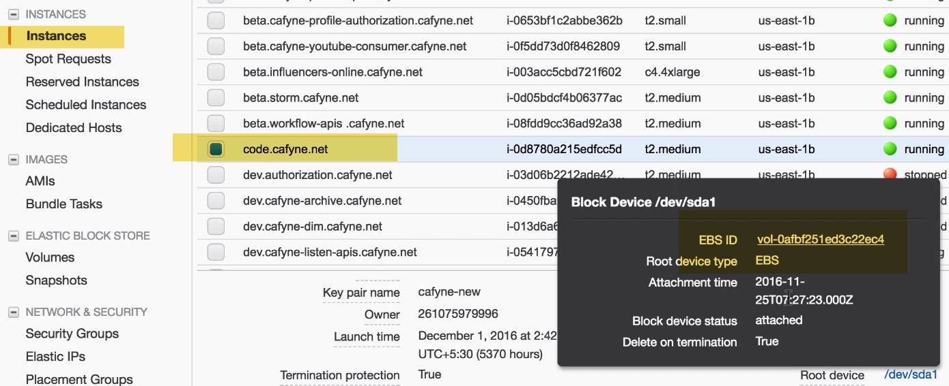

Click EBS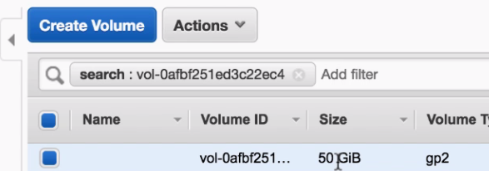

We have to switch off instance and make auto snapshot

2.)Create AMIs---It will create full backup

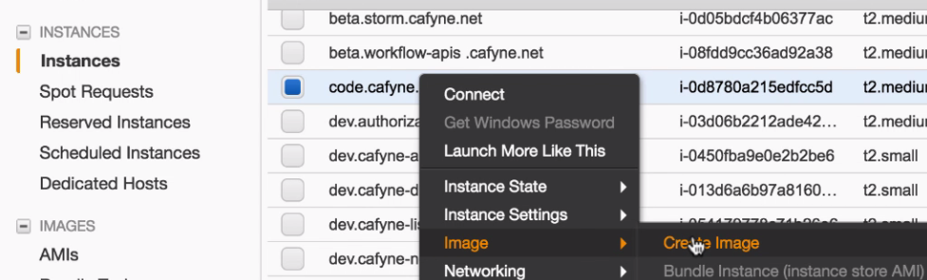

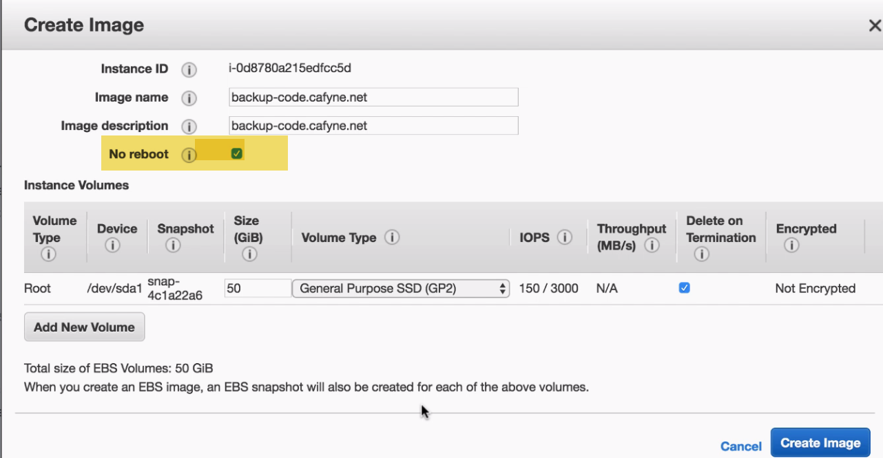

We don’t want to reboot when making AMIs.

Gitlab Service server shouldn’t reboot---as checkins may be happening..

3.)(or)

4.) **Autobackup for usual git-server:**

Let say we have 100 repositories…Keep them in a text file..

For every 5 hours we have backup of repos on remote m/c.. We can cleanup or keep it for 6 days.

Take Backup of repos ..not OS.

I does backup only…Not ACLS

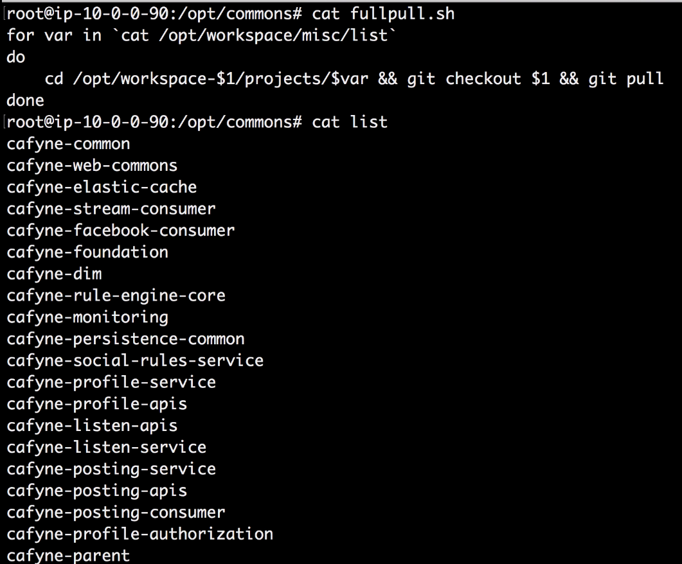

**-🡪Gitlab also have APIs**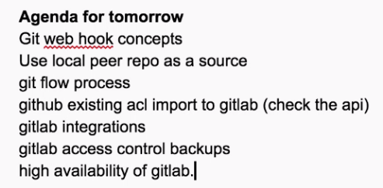

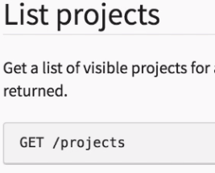

We can get all projects list here..and put in text file..

--🡪

# Class:7

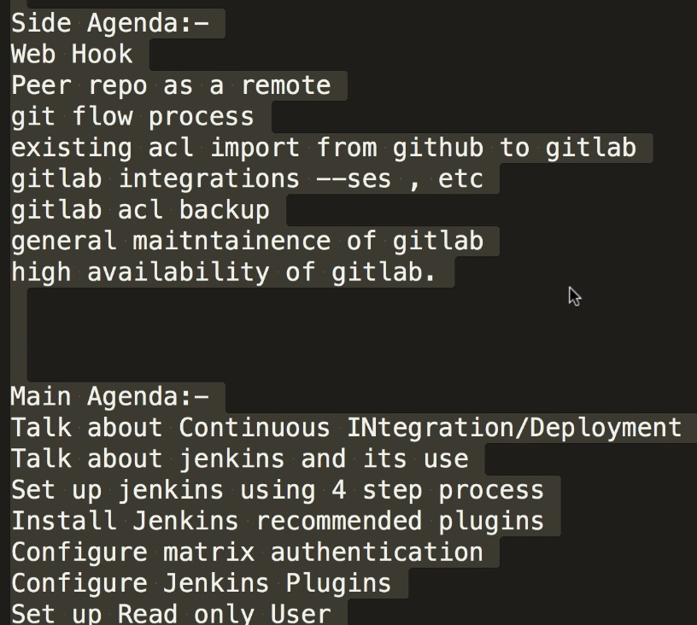

-🡪Webhooks:

For every Project, there will be webhook, specific to project.

We can set to do certain actions.

Goto Settings->Interations->Webhooks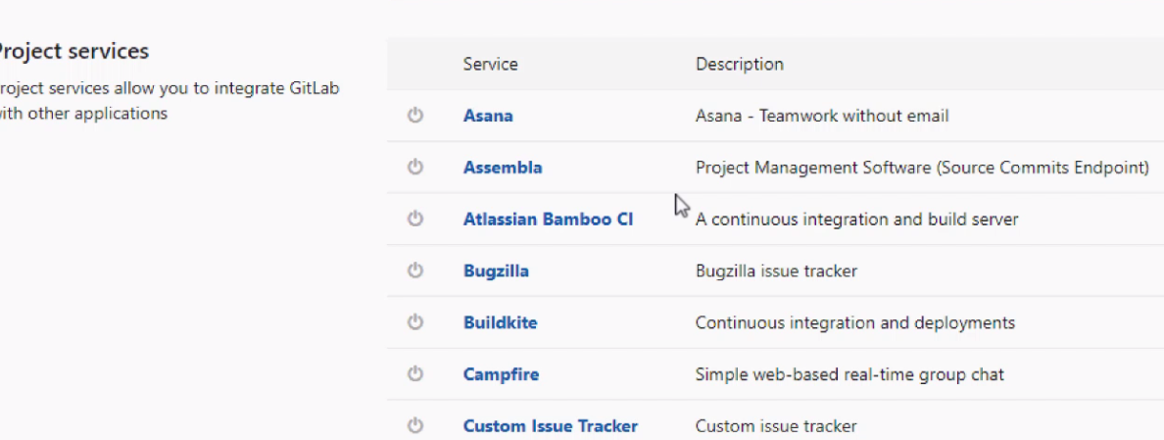

We can have lot of 3rd parties also..

Integrated gitlab with email webhook.-🡪 whenever push is there, send mail

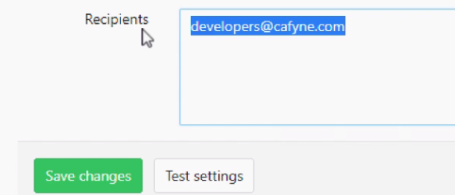

When push is there—it will go to Developers email..

Email sending part is configured using AWS SES part.

Class 8

# 

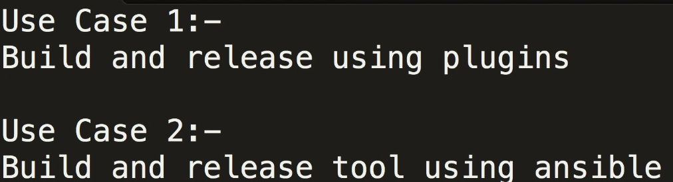

**-🡪REAL (how people are authenticated):** If startup with 5-10 , not required to setup dedicated authentication server.

For LDAP server on AWS---on t2.medium---39$

1.)Jenkins Own database with Project based-matrix

NOTE: Select Users to SIGNUP In Jenkins OWN DATABASE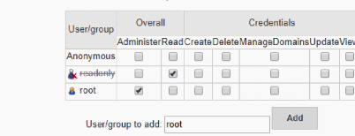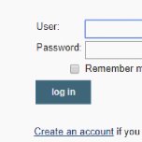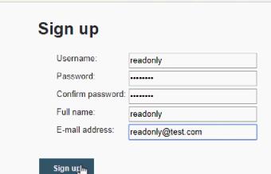

Now…Create some A/c..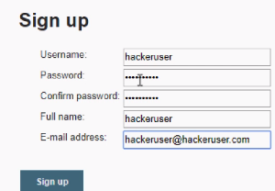Because signup page is activated using Project-matrix…

When we have matrix proj. enabled, and provided access to specific users..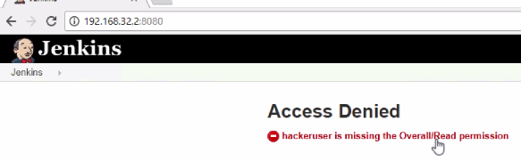

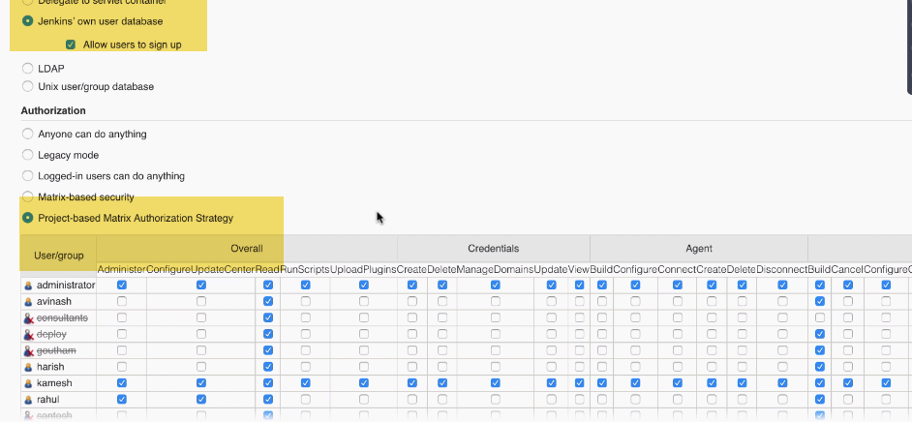

2.) Setup Centralized ldap server (openldap) can be used for authenticating multiple systems:

Graylog(Using Graylog ldap plugin)) , login server, ELK, SSH logins authenticated by that..

Master-slave mode can be used for openldap in HA mode...

PHPldap admin--GUI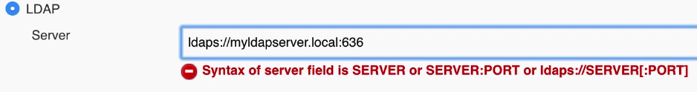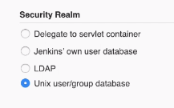If we have Jenkins m/c with users, and want to utilize for auth.

ROLES: LDAP roles Doesnt apply in Jenkins… Need to create separate Jenkins roles..

**Matrix based vs Project-based Matrix**

Matrix: Jenkins wide…not project based  
Projectbased:

We can do at project level.We can override settings if set ant Configure Security Page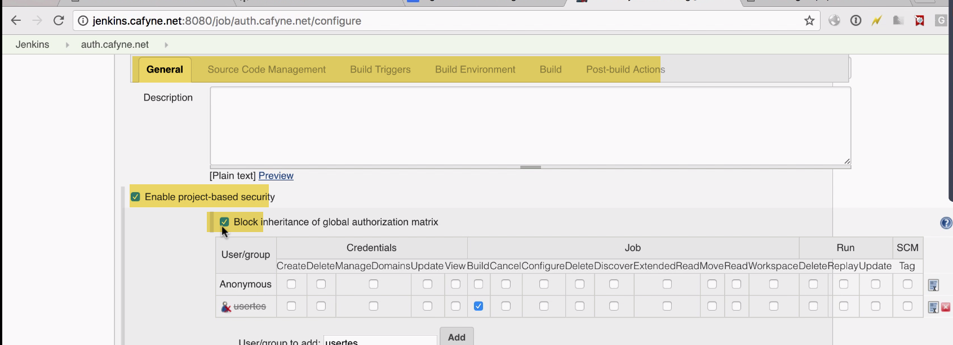

--🡪Global Tool Configuration::

**REAL: Backup: 1. snapshots 2. AMI**

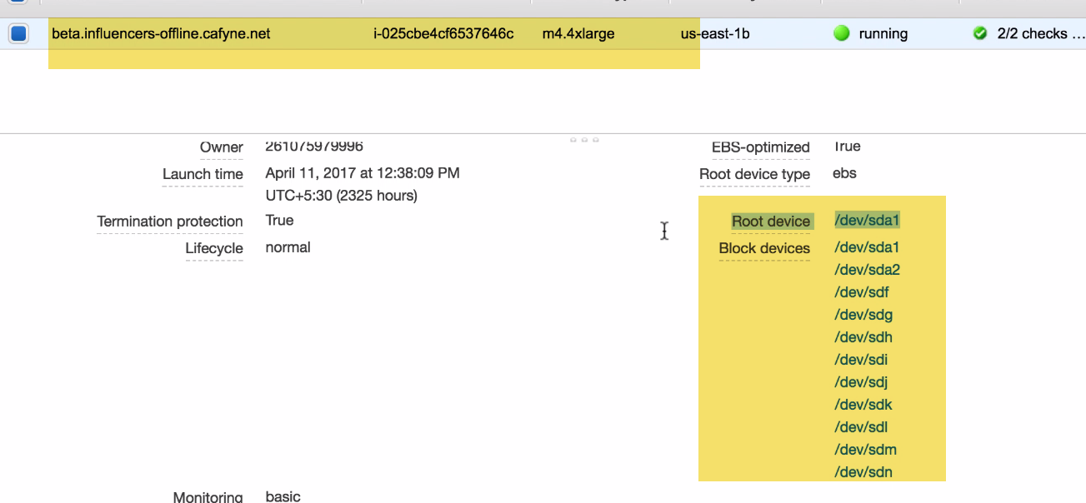

For this scenario.. Not recommended to Take AMI..AS AMI will take backup of root device only..

Better take snapshots of individual volumes.. 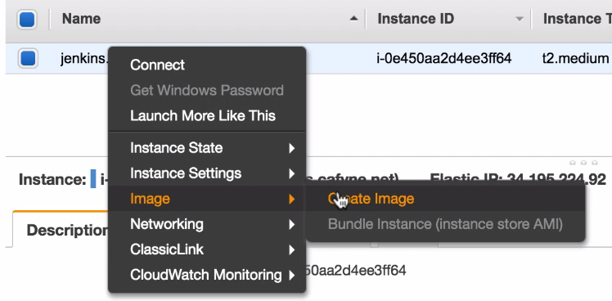

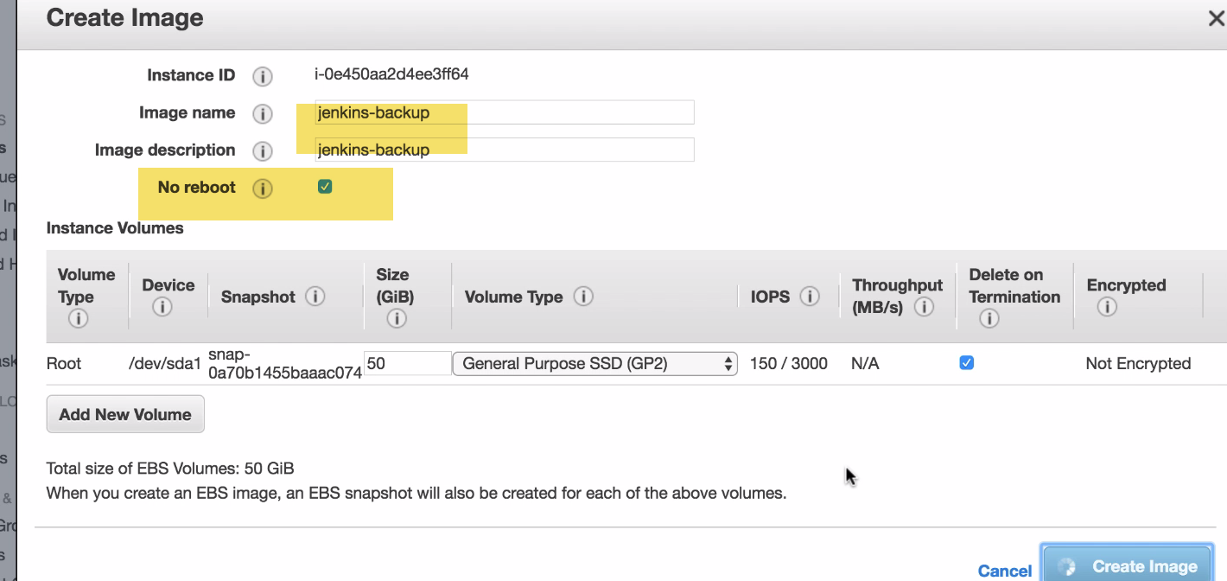

No reboot as it is Prod m/c..



For DB like PostGres., need to shutdown

For jenkisn, no much s/w changes.. just logs and builds..

---🡪Plugins

For HTML reports

For code coverage

-🡪 With Jenkins security:--🡪 Becareful it can reset all security credntials



If we forgot password ,set this flag false…Restart Jenkins

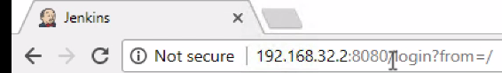Remove /login at end….Just use IP:8080

We can login directly…No security is there

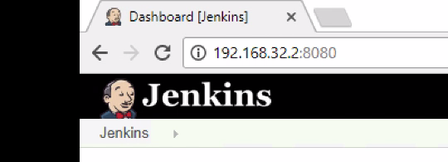

-🡪Forgot admin password:

Configure Credentials->

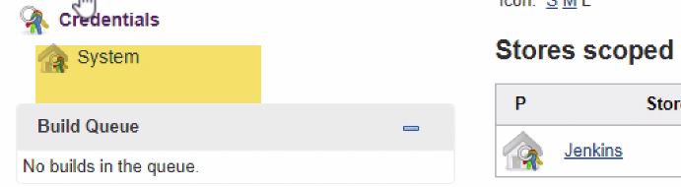

System-> Add Credentails

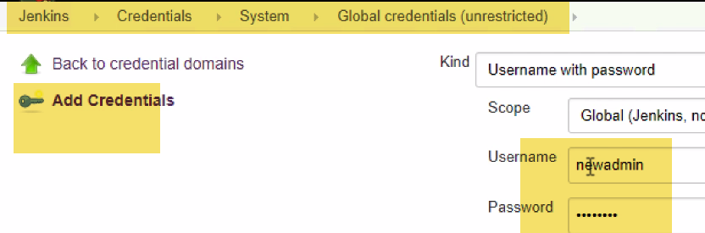

We have NEWadmin now..

___> Jenkins backup

1. Plugin

Allows to backup

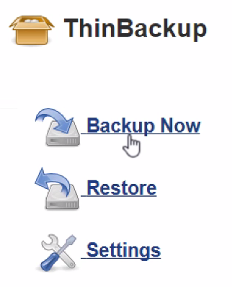

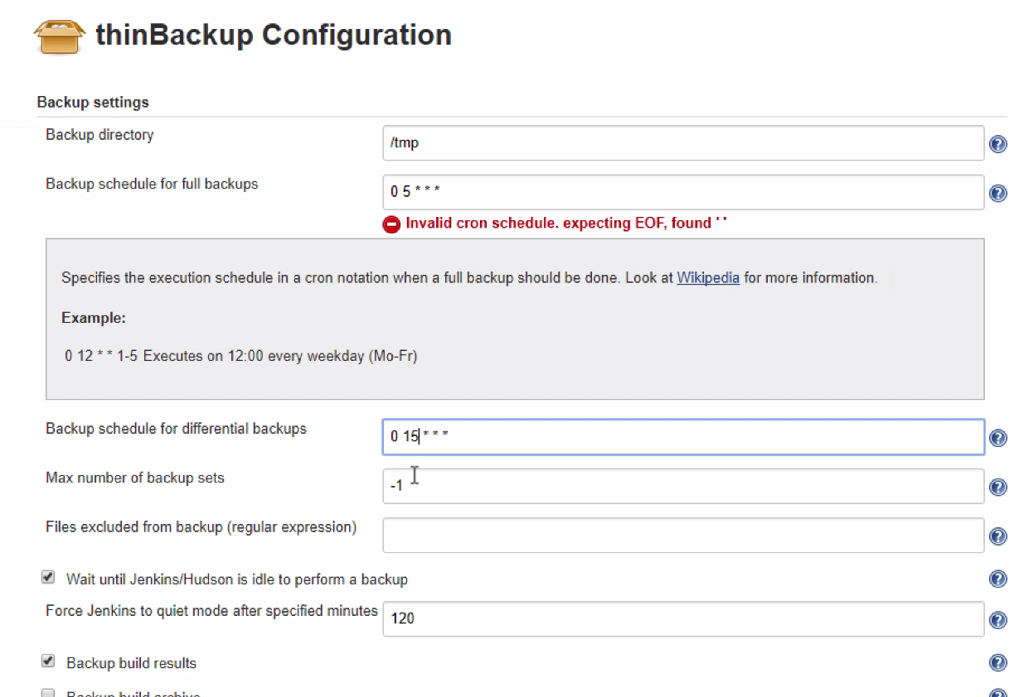

/tmp-🡪 because it is accessible by all users on Linux FS

Fullbackup schedule: 5M MORNING EVERYDAY

Differntial backup: 3 pm 🡪 So that any change done by DEV team in day time..

-🡪 

For installation for java,maven,docker---Automatically

With Plugins, option will come up

# **Class 9**

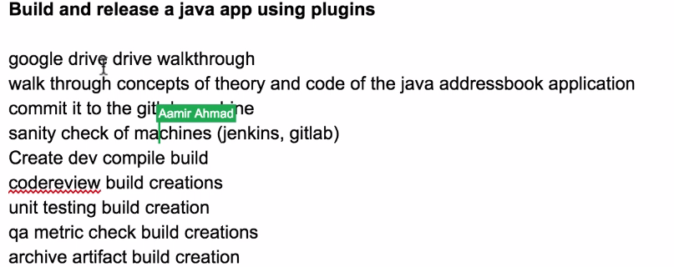APP.used to save name, DOD,emails,Ph. nos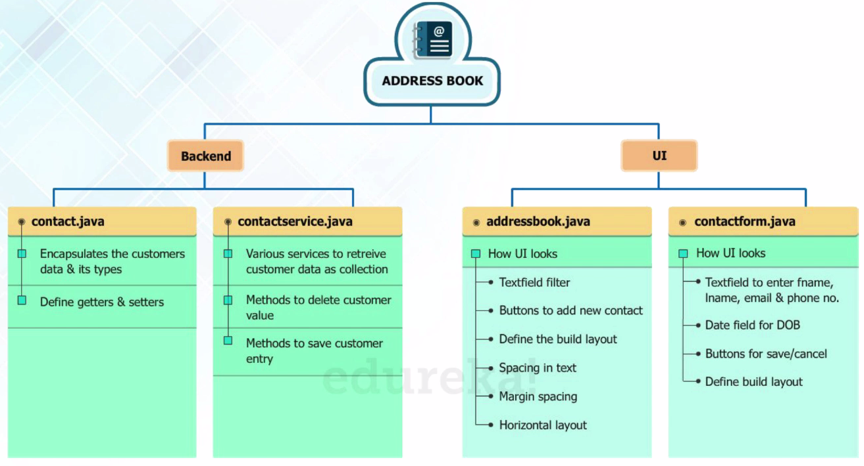

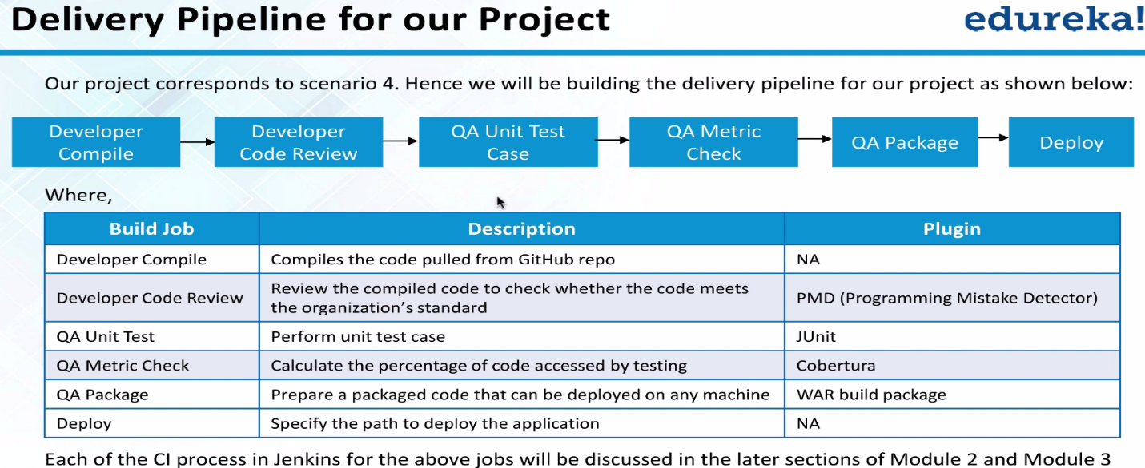

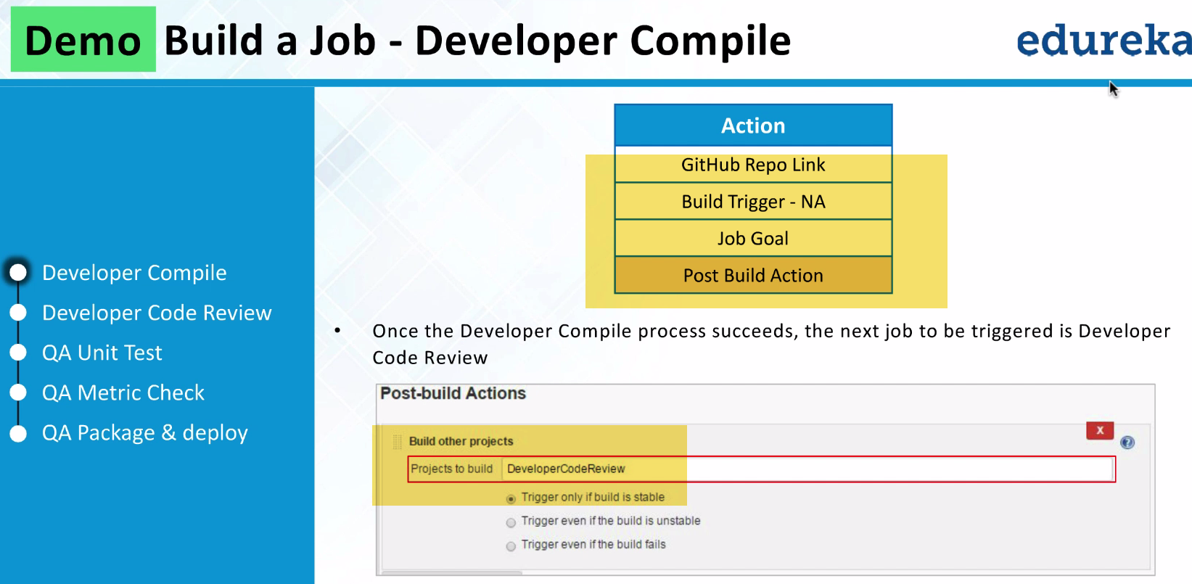

🡪 Delete Gitlab project 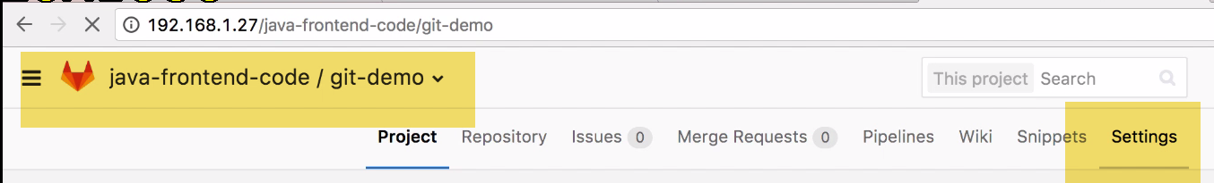 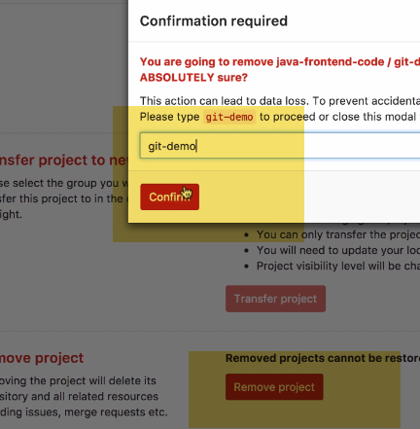

New Project

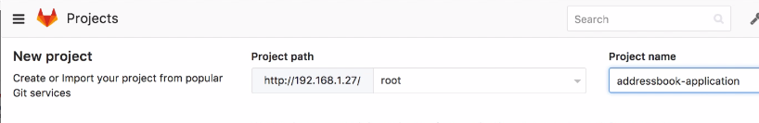 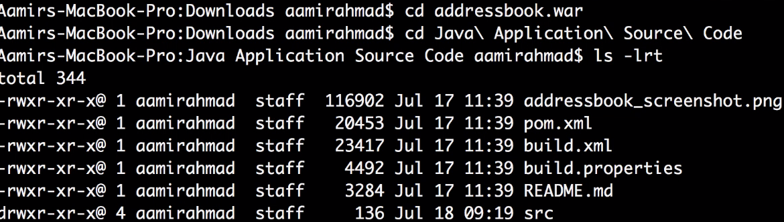



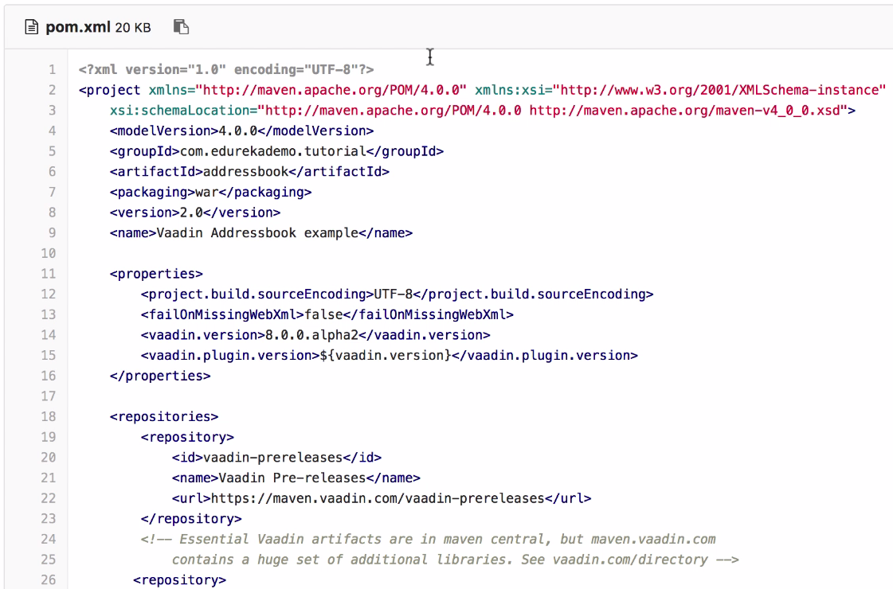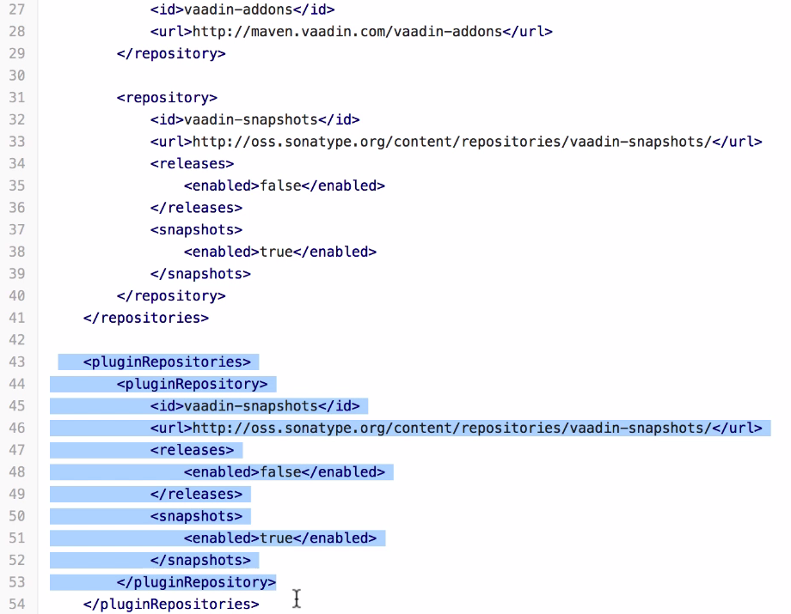

As Devops Engineer: Need to worry of Plugin repository ----URL Get Vadin plugin from there

Dependencies fetched from vadin.in---Remote

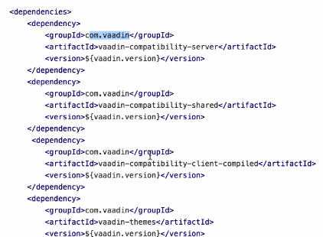

Comment is there---LOGGING (used for log Purpose)

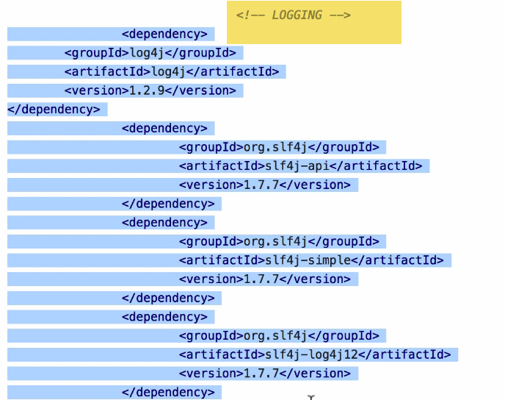

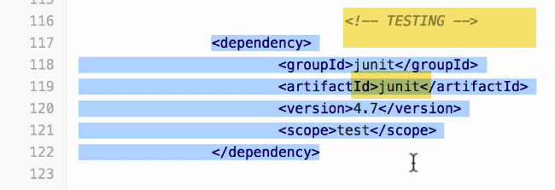

NEXUS: We have dependency jars stored on Nexus..

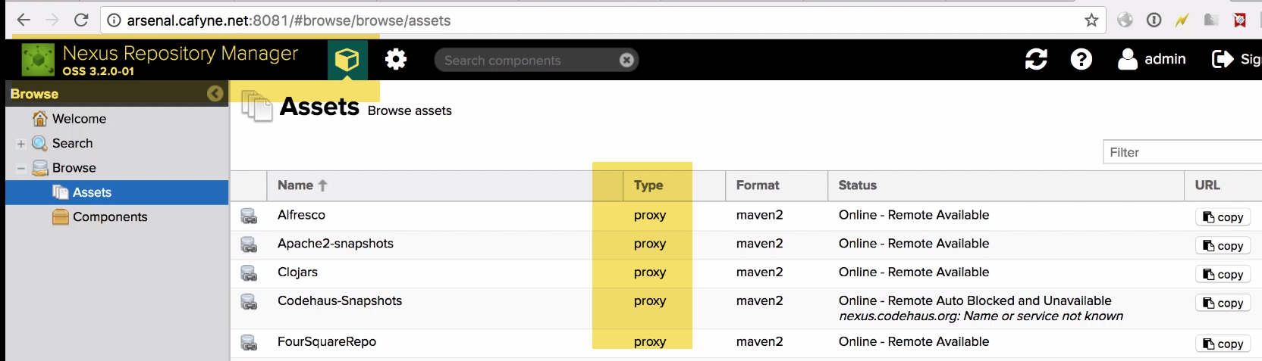

We post proxies as we don’t want to rely on online repositories...

**1.)**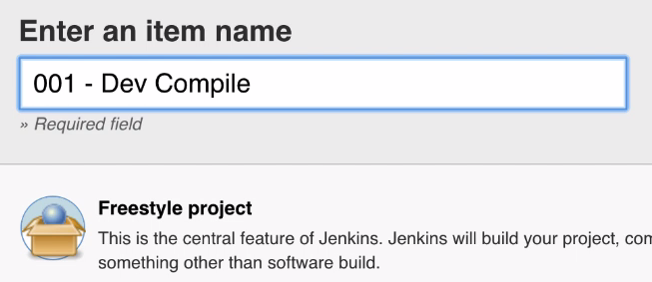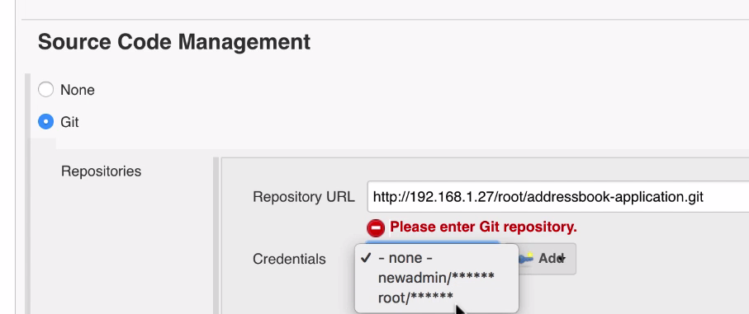

**2.)**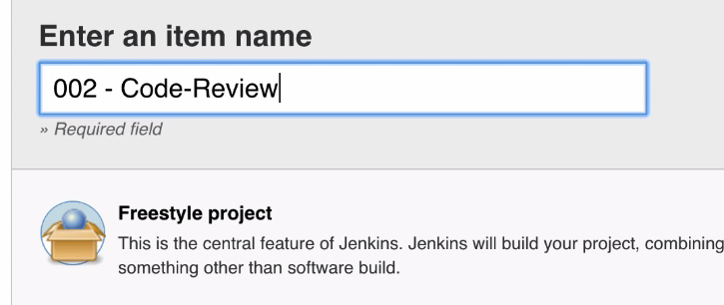 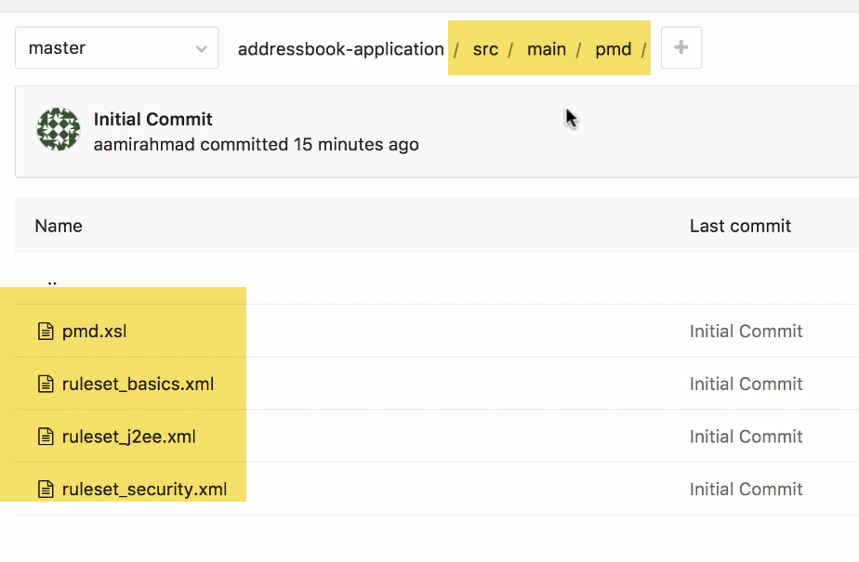

Given by Dev/QA---(Rules what it should check)

Security what it should check.

1. Invoke top-level maven targets
2. Publish PMD reports(for post build ction)---PLUGIN---Install It

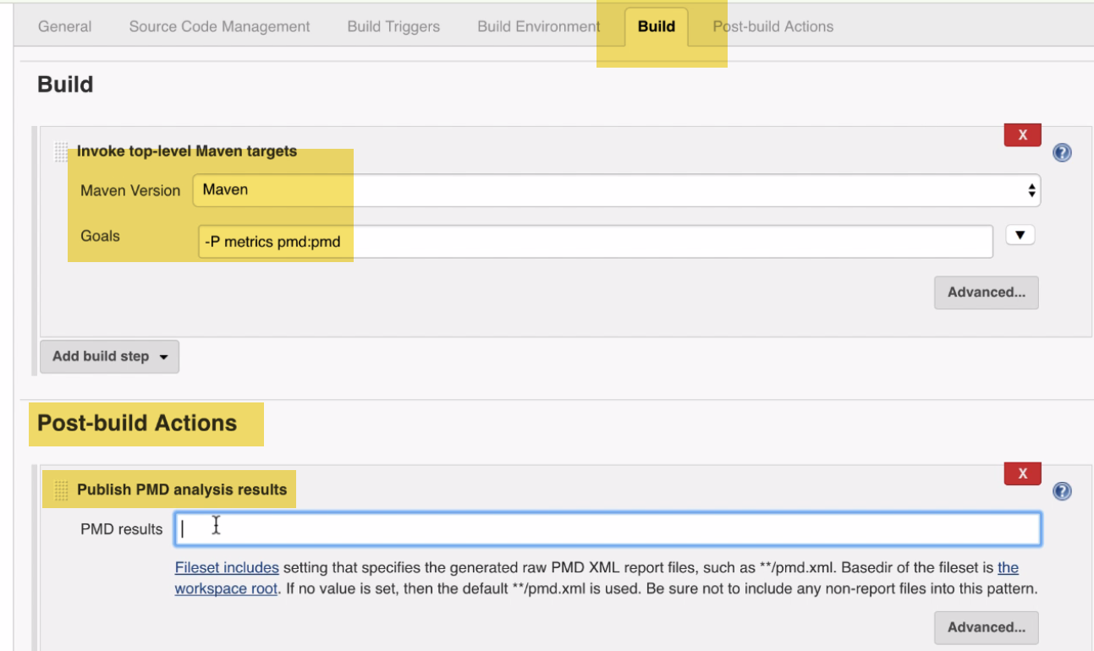

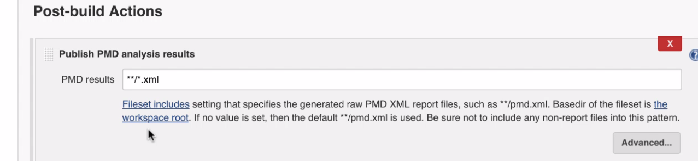

Issue:

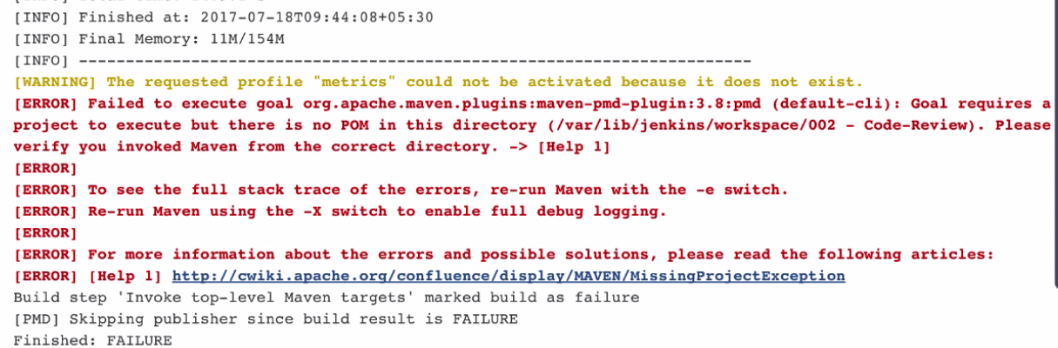

**Sol:** We have to specify Git in every free scale project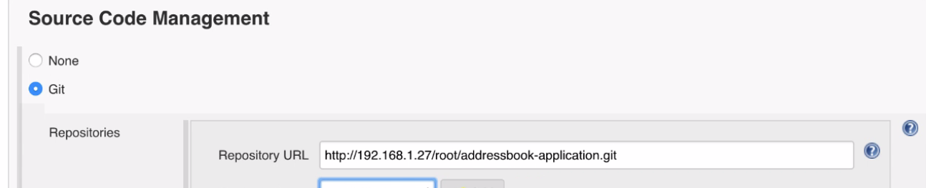

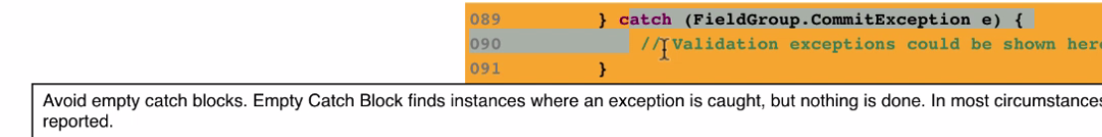

1 million lines of code—with 10000 empty catch bocks that can effect app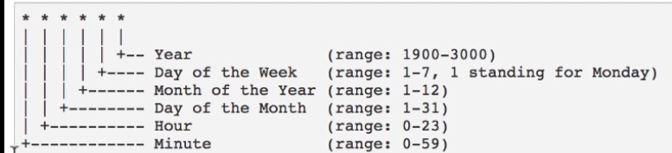

5:30 am morning everyday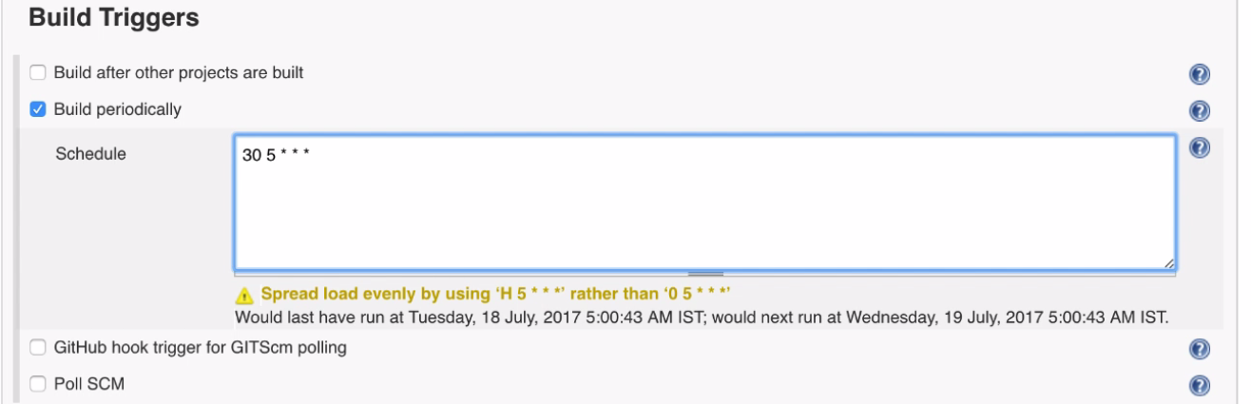

Scenario:DBDump twice a day…To keep DB safe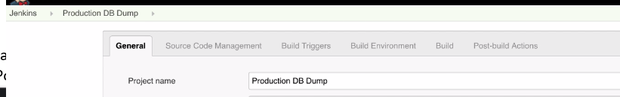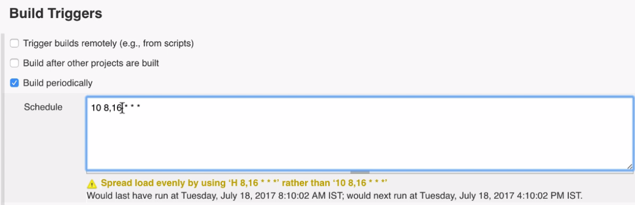

8:10 in morning, 4:10 PM

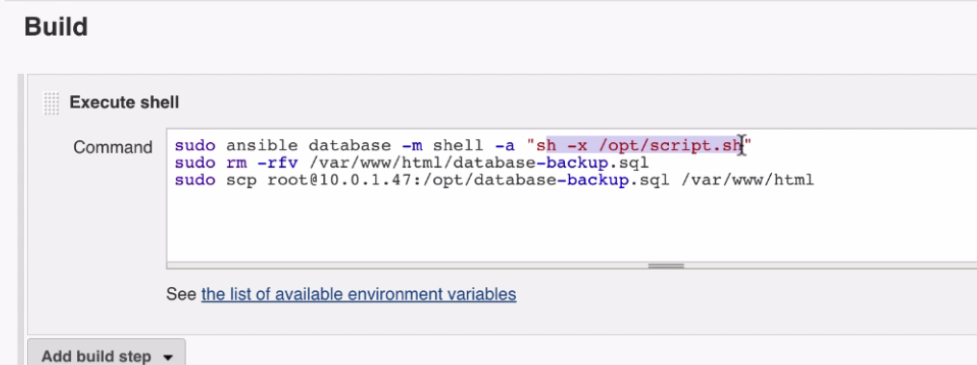

🡪webhooks: 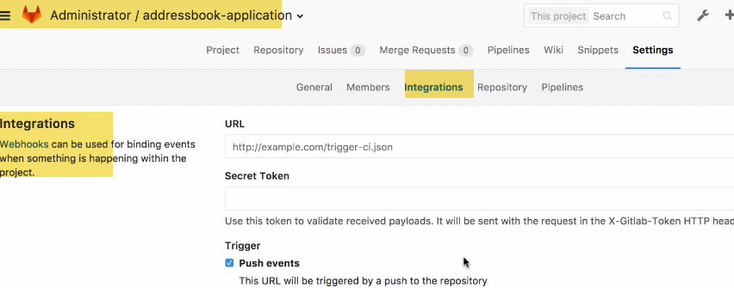

Whenever developer commits code in Version control repo..Automatically wants build to trigger

-🡪Java🡪maven

C pgm🡪 automake

Pom.xml--------When build is checkedout ,Pom will come into picture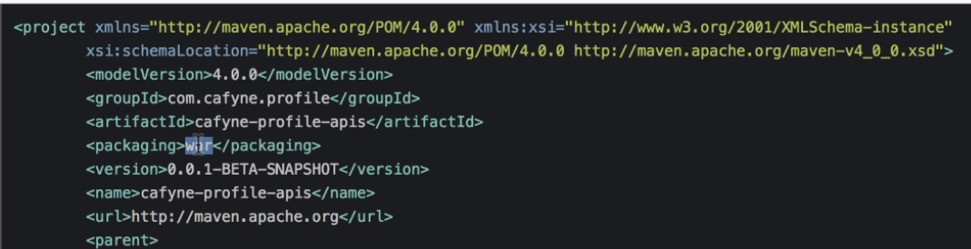

Package in war/ear

ArtifactID🡪 outputfilename.war

Nexus

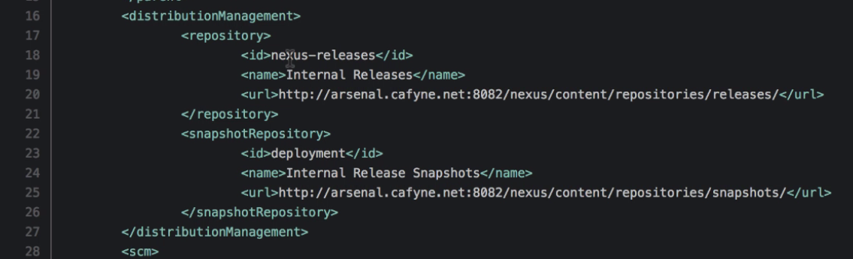

Git

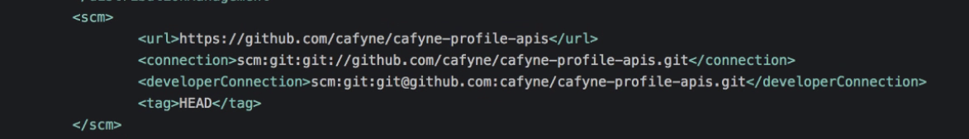

Plugins req

.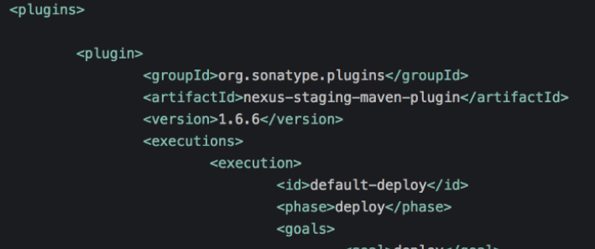

3.)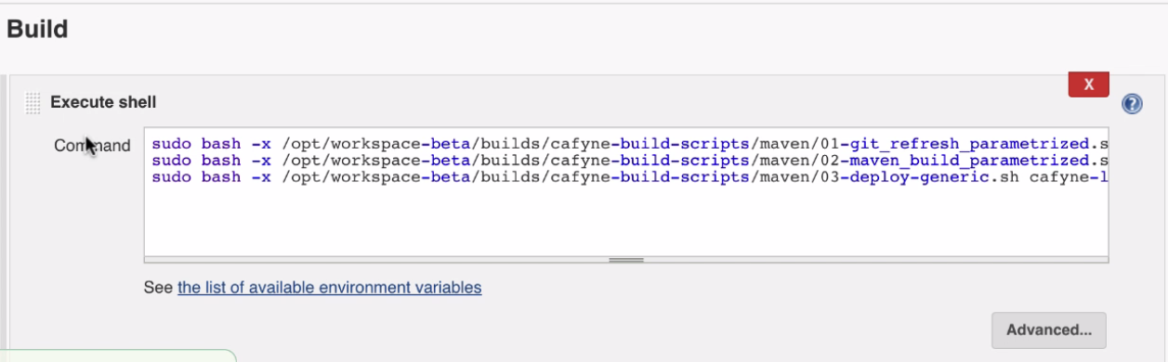

We have 3 scripts:

Gitrefresh---with param

Maven build with para

Deploy with para---Will call ansible to deploy on server

# **Class 10**

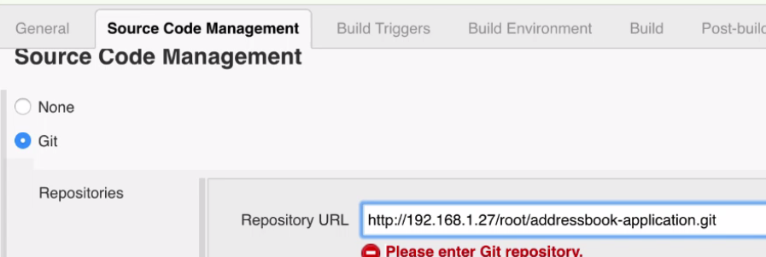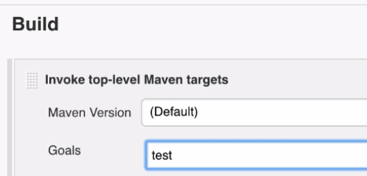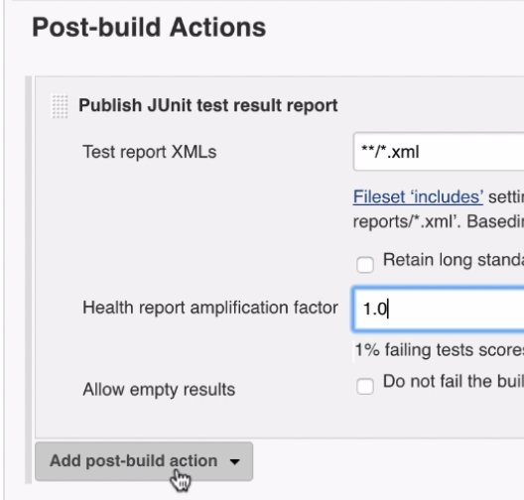

For those internal, not available on Maven…we keep it on Nexus

On Maven repo---we don’t store…Its huge and widely available---No point in huge

Let’s say a developer wants to build Youtube service localy. Kicked off maven build, and it have 10 dependencies of 10 jars..We will get from arsenal.cafyne setp on cloud.

It’s reason for setting up Nexus. We don’t want developers to depend on others like SCP, import eclipse,etccc…And Also build Dependencies manually..

Where did we setup this??? Nexus—jenkins??

Settings.xml in jenkins server in repository.

---4.**) Cobbertura: Code Coverrage:**

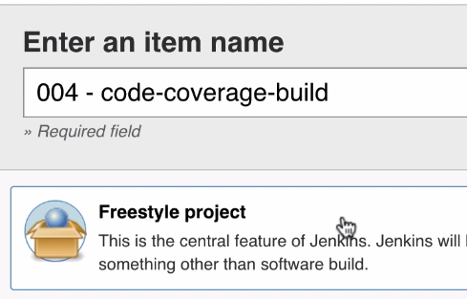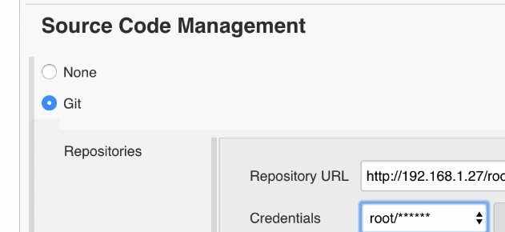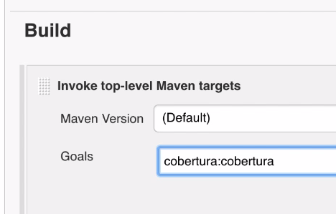

**Issue:** 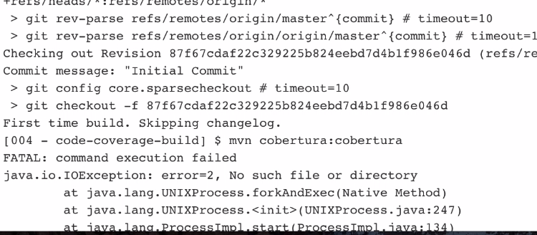

**Sol:** 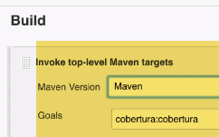--🡪 Select Maven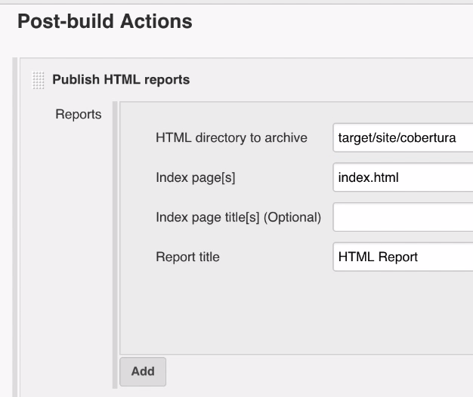

5.)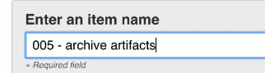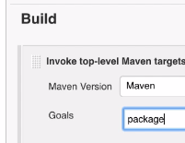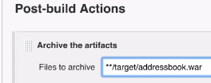

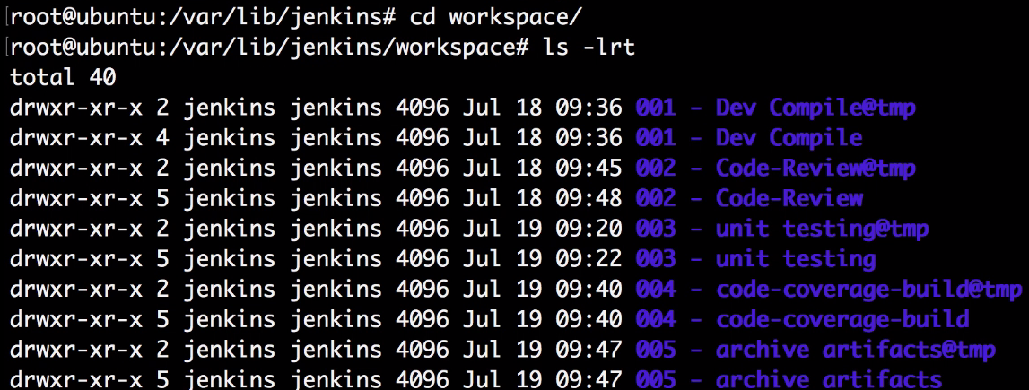 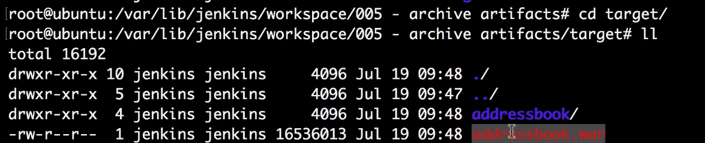

1. For Dev Compiled-🡪 no target
2. Some reports??
3. 
4. 
5. 

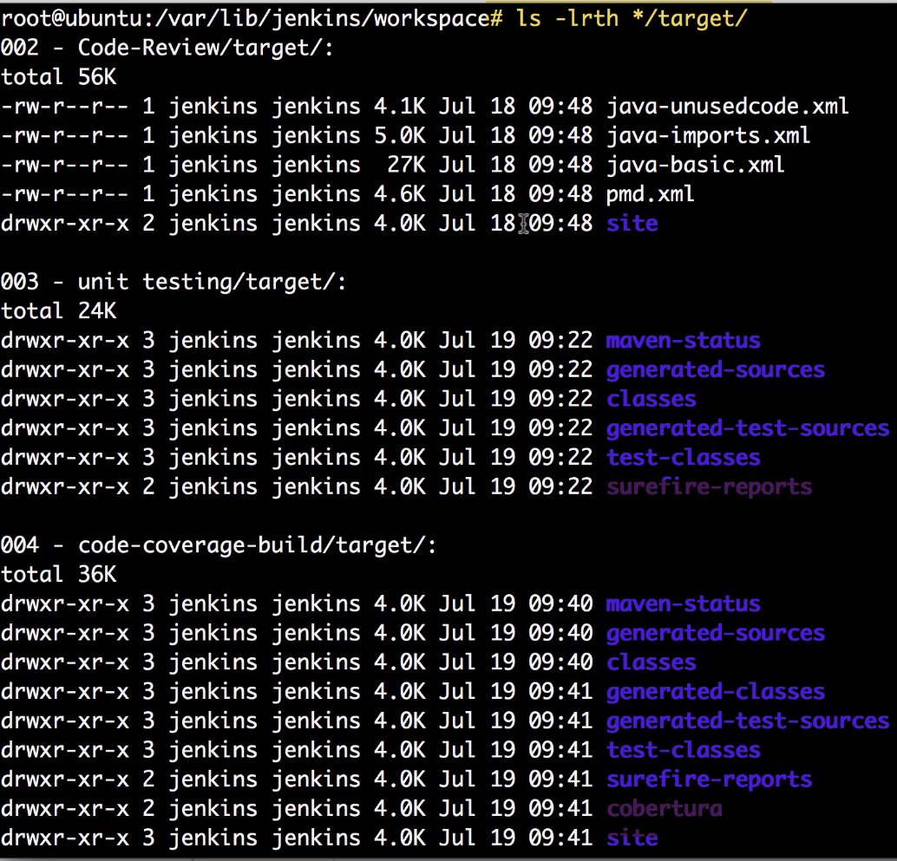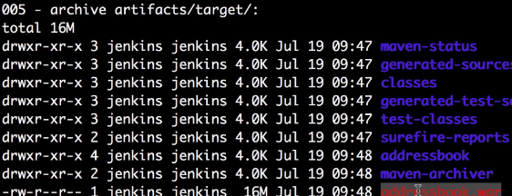

6.) 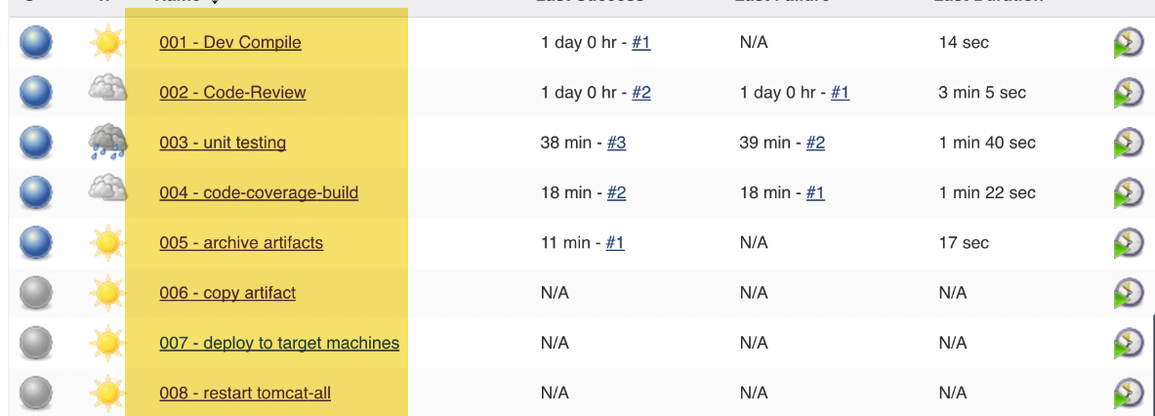

This is for single microservice.

There can be multiple services in env.

**Why do we need Jenkins.. Why cant I use script??**

If we have 50 microservices,you can create easily pipelines…Define relation b/w env, applications As well..

# Class 11

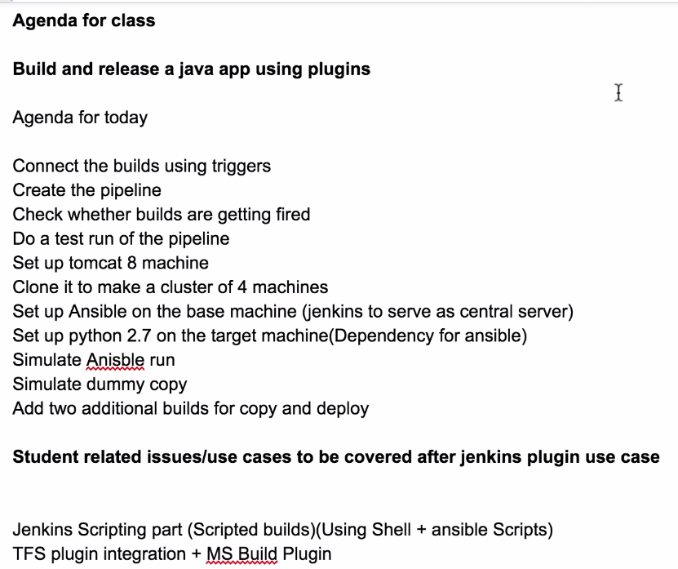 Elastic IP, Although it shouldn’t be elastic but reason why call elastic: We cn port that IP to any m/c in ur infra… 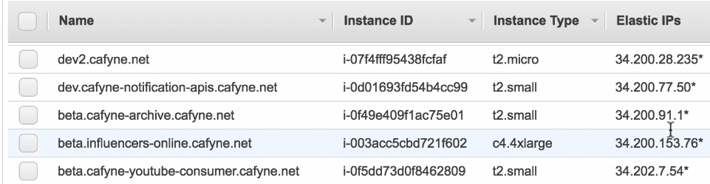

-🡪How to make IP static in AWS??

In AWS, 2 IPs for EC2 instance…1.Public 2) Private

Both remains same…until reboot. Changes after reboot …

We can allocate max. 5 elastic Ips in a/c by default in region…

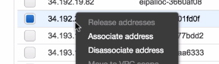---We can attach/deassosiate.

These elastic Ips are mapped to DNS entries..

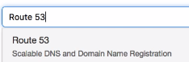

In this we have Hostname mapped to with Public DNS with elastic IPs

----🡪PIPELINE (Mostly use post-build actions to connect)

When we create pipeline for Prod. Deployment:

1.) Create merge strategy---Git stragey (because it mka

1.)

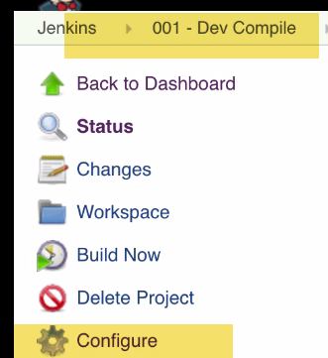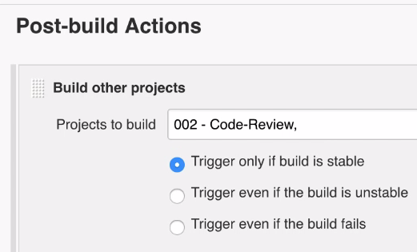

Build 002 after 1st one successful..

b.)We can see 001 is connect by downstream project

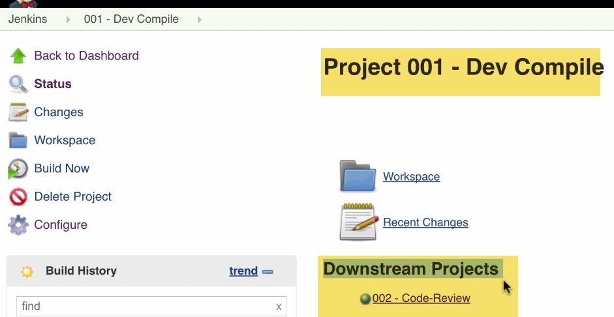

c.)If we click 002 we can see 001 is upstream 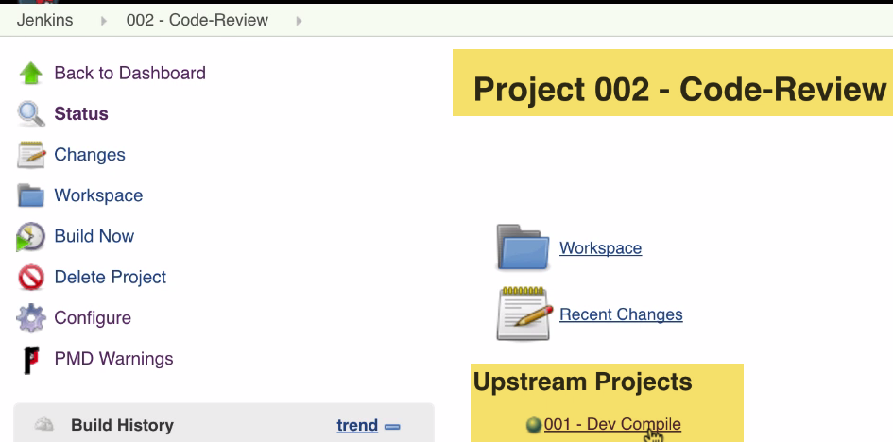

Whenever 001 is done, goto 002---This is called Upstream-Downstream

-🡪002 and 003 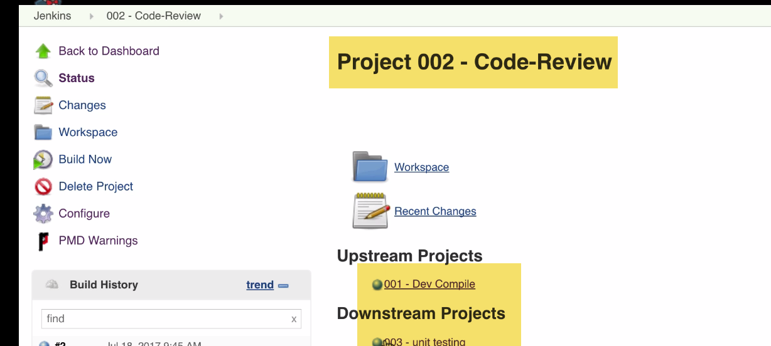

002 build have upstream and downstrream.

Downstream is what it would be triggered by this build

Upstreaam:Which triggers this build.

-🡪003 and 004:

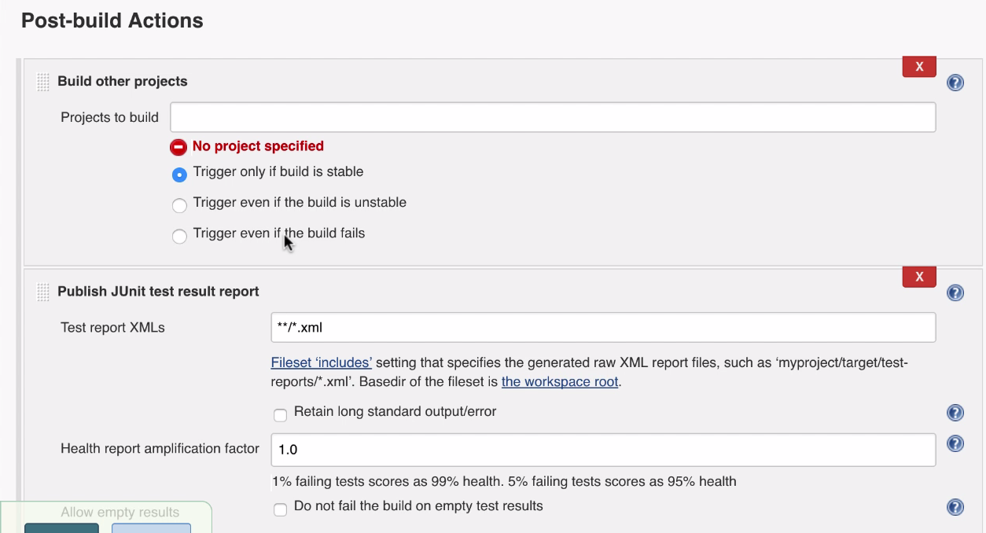

Note: Here Build other projects came above Publish Junit…What happens??

Next build 004 will get triggered and then

Junit Test reports will get executed…I don’t what that…So???? Replace..Drag drop

I want Junit results first and then trigger build 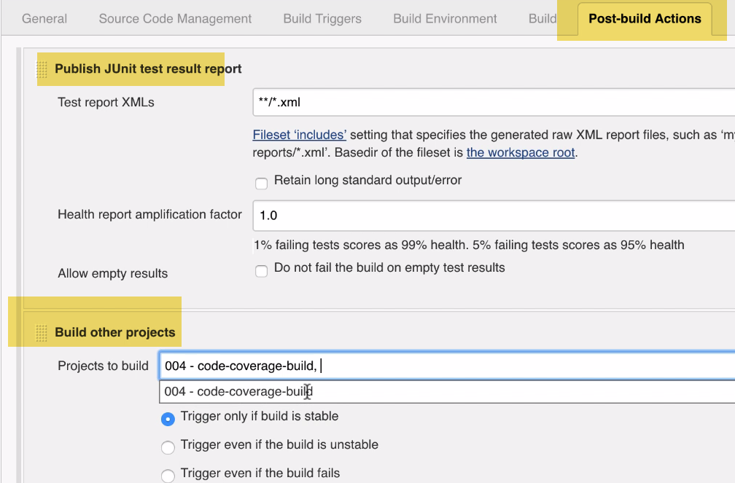

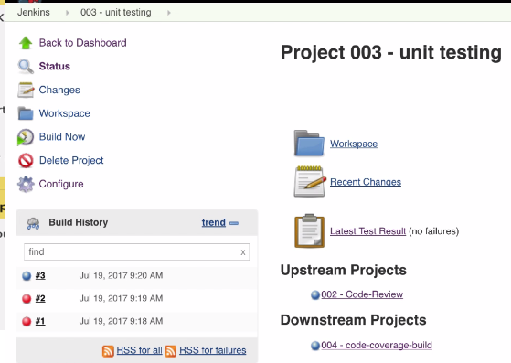

4.)004 and 005

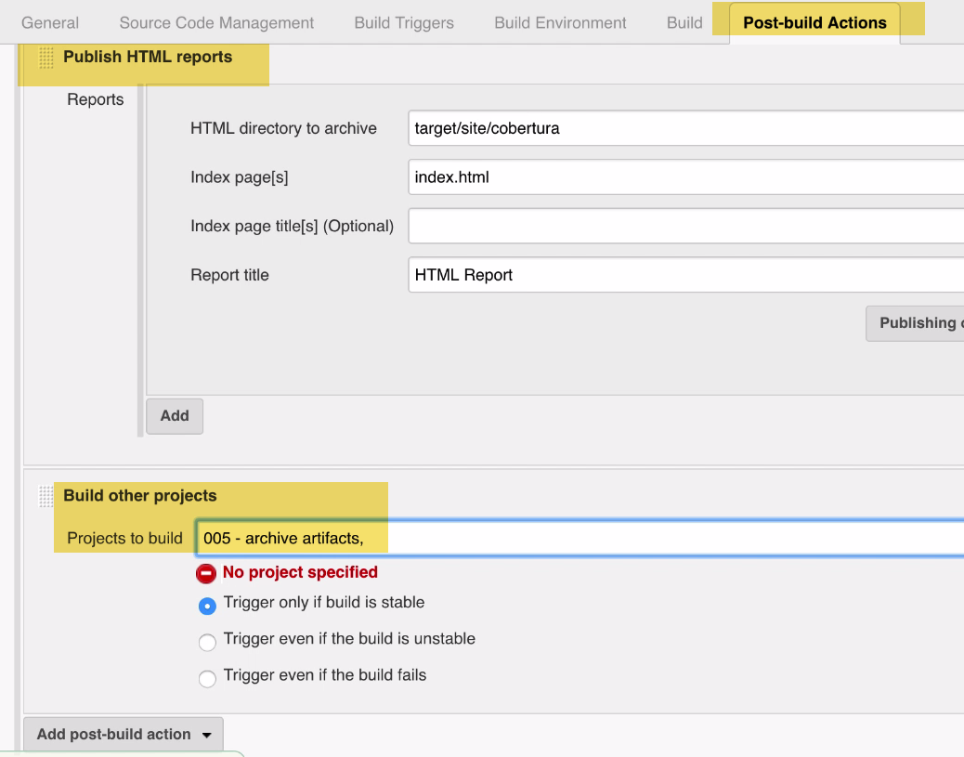

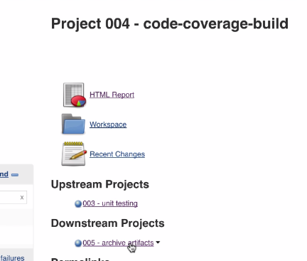

5.) Build Pipeline missing

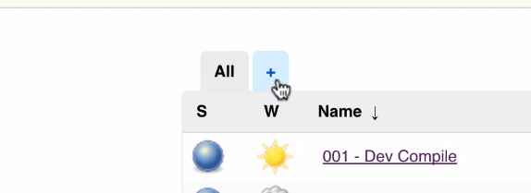 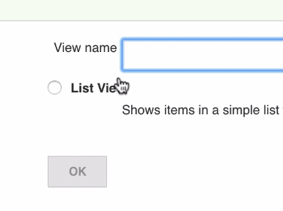

Install it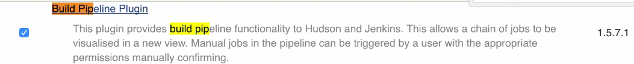

Allows to connect multiple builds

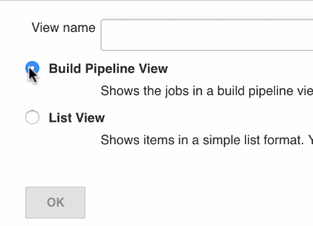 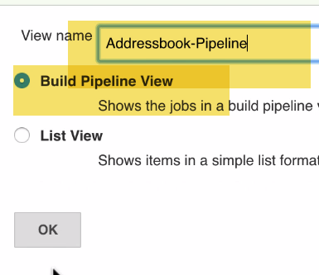

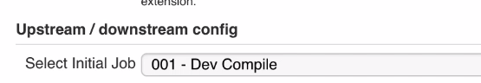

No need to do anything…Just select 1st job only..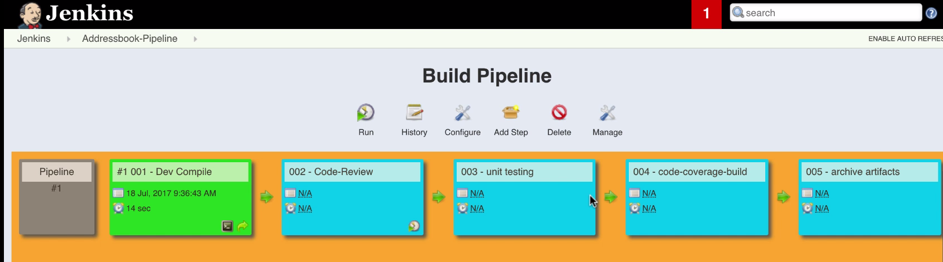

This is Build pipeline..(What Connevint gbuilds and sequence of build to run)

**Why is it important?????**

**Lets say we have 100 environments…100 app..**

**How many builds??? ---100x100=10000 builds**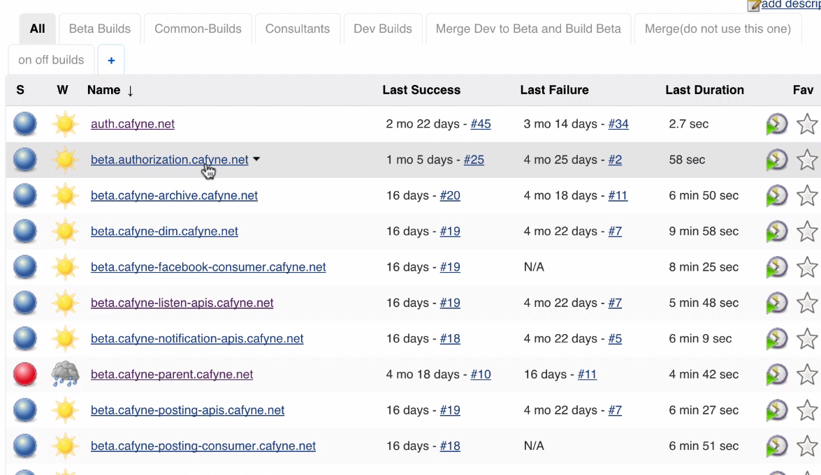

There are lot of builds..It’s very confusing for Developer to guess why build should I …

Now, if we have pipeline:--**Whenever release from Dev to Beta..We go there…Click run**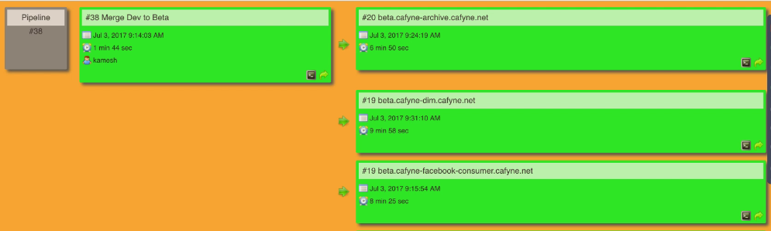

**There is no need remember what all builds and in sequence to run.**

**Especially useful in Prod... when doing release and don’t want to mess things up**

**6.)** Run Pipeline

Scenario:

In Cayfne: Have 2 env: Dev,Beta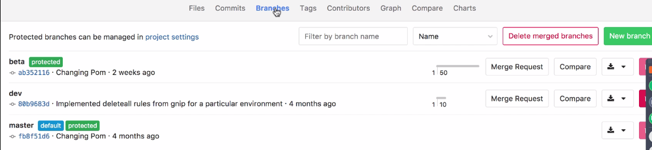

Dev🡪Developers...

Beta🡪Demo to client

We didn’t want hindrance b/w Developers and client…Although Timings are different..

Dev will be deployed 2 times a week…We follow agile

2 weeks/3 weeks sprint.. At beginning of sprint, we are going to discuss about tasks and targets to be achieved..

Excel shared across

Jira for tracking…

🡪Beta is protected.. Since we don’t want to commit to beta..

Developers cannot push there...

I don’t want my user to do merge.., and end mails with my email ID..(I may leave org..But it will use my Emailid)

When we want to release to beta after 2 weeks sprint.. We need someone or give master access to do.

Create a generic user in Gitlab and jenkins... Deploy user (admin)...and added Jenkins keys to user

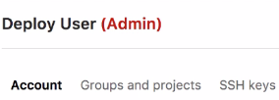

Whenever merger is done from dev to beta, gitlab sends mails Deploy user(Jenkins user) done merge..

🡪Micro services feature segregates as many features from main line..

We have about 25 microservices.., which we want to build and know sequence build to be done..

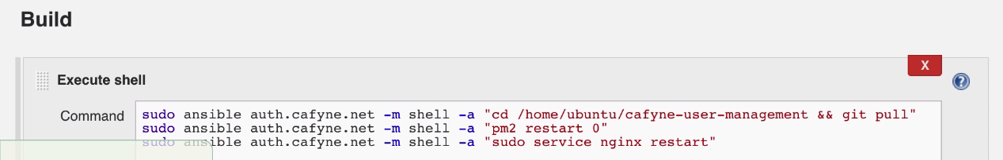

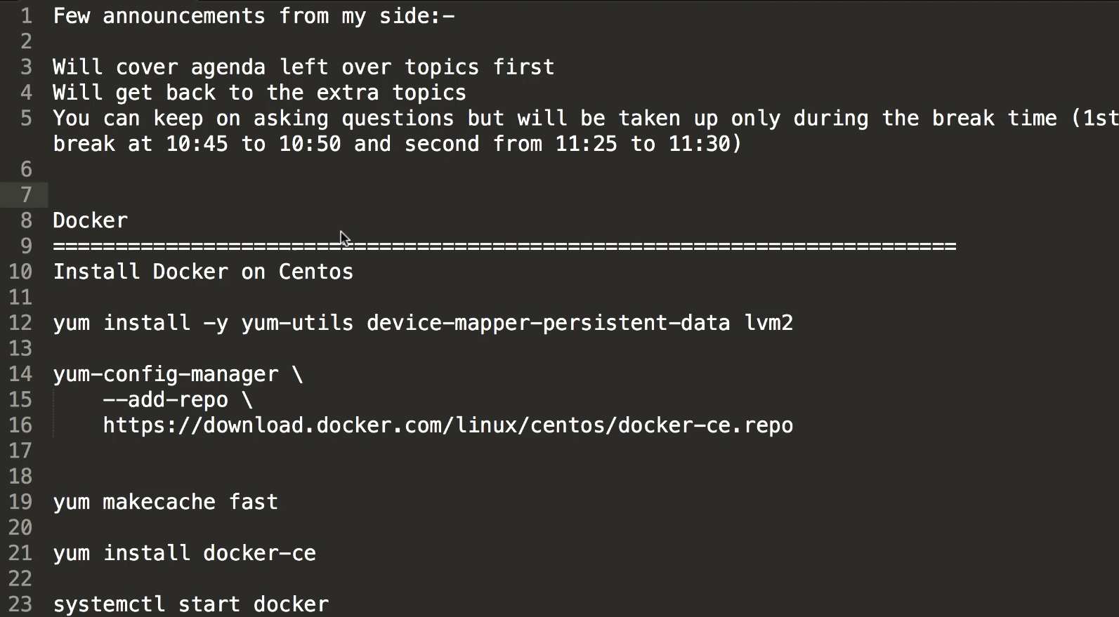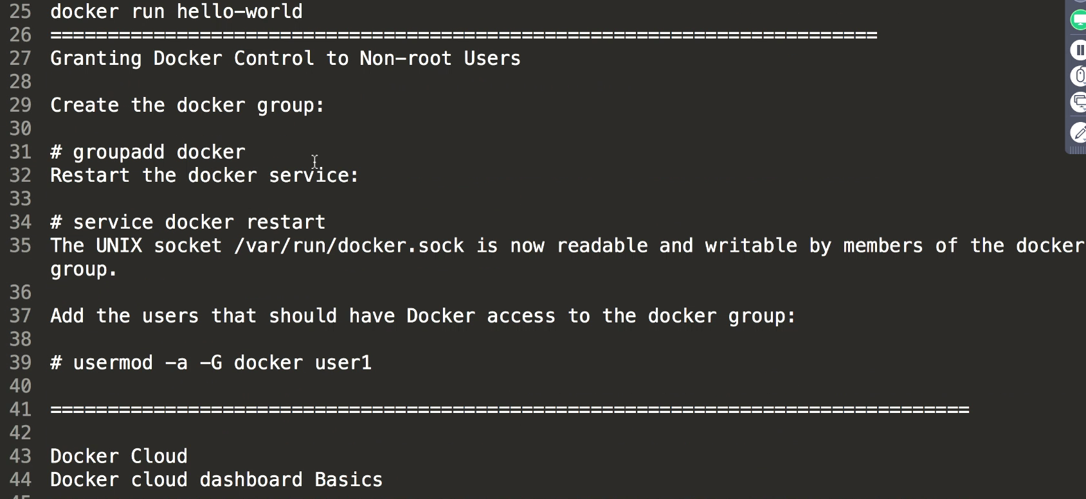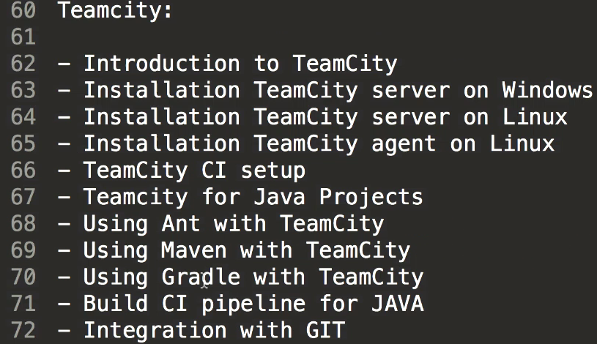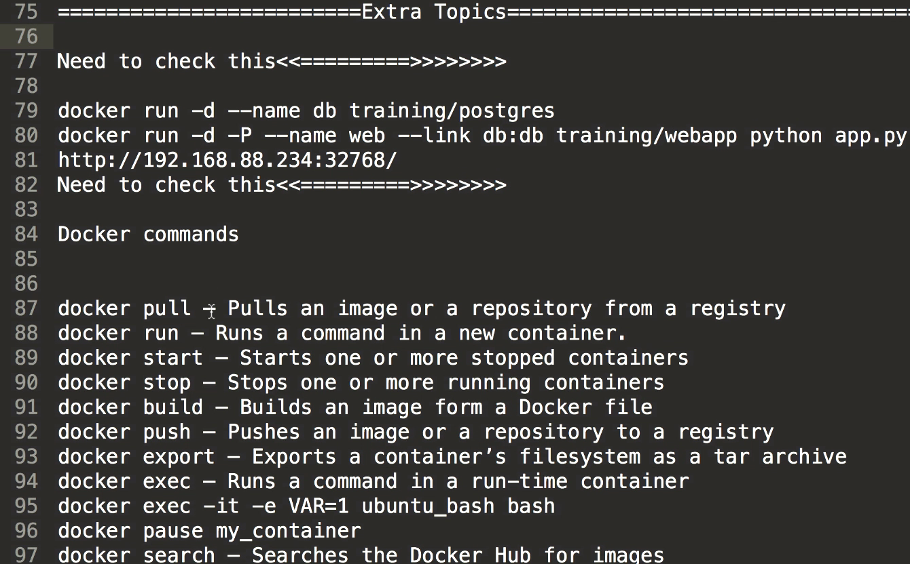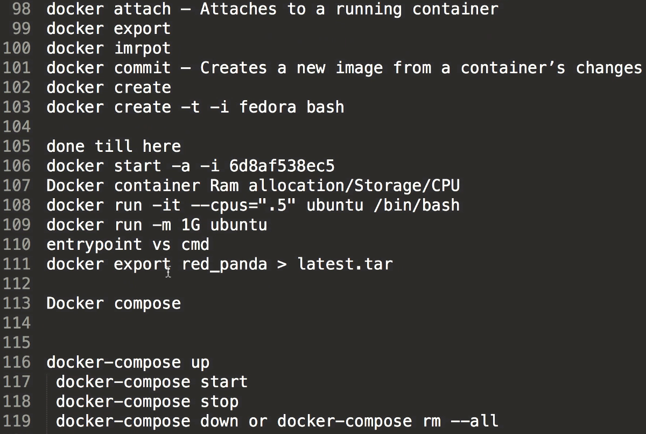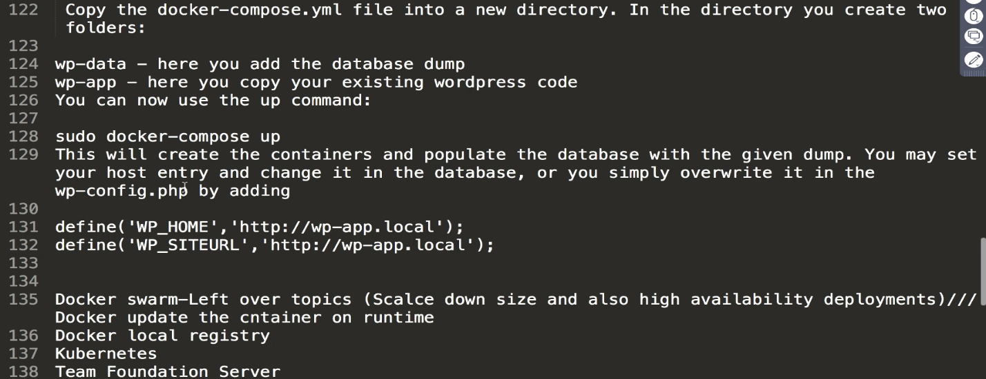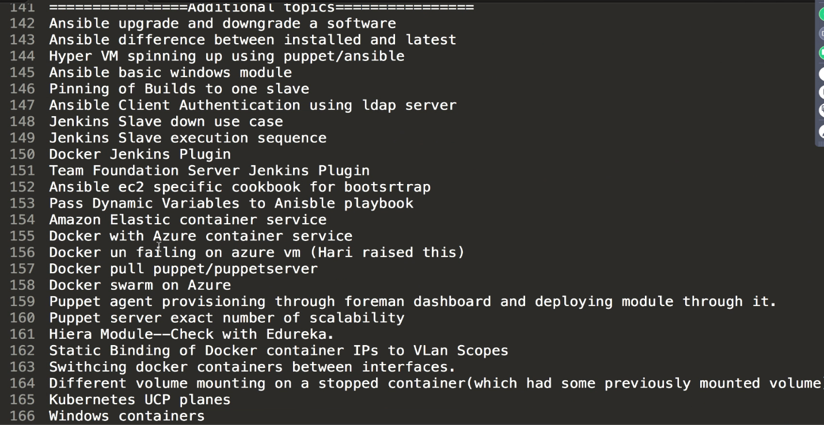



Update repolists

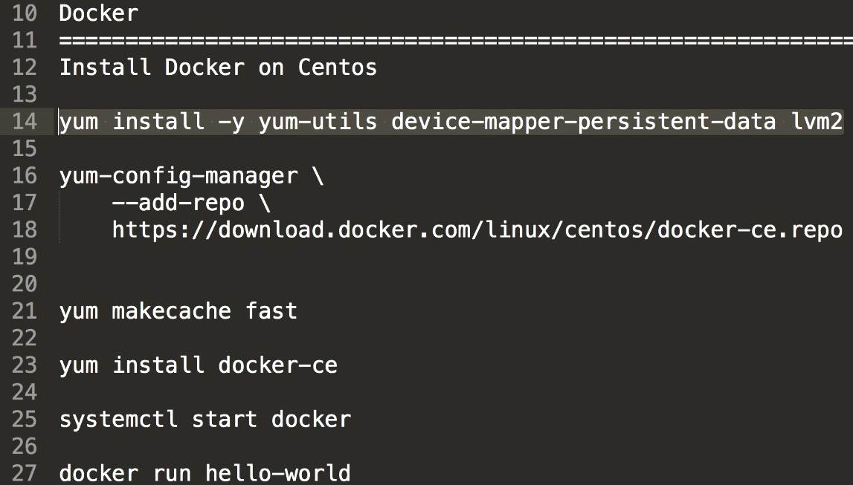

Code: Game of Life….